Dear Emergency Supply Chain Manager,
Congratulations on taking the first step on the important journey to help your country prepare emergency supply chains (ESCs) for potential disease outbreaks! Your effort will pay off in lives saved and resources conserved in future emergency situations.

Who should use this box
The materials in this box are designated to be used primarily by a small national team consisting of:
- ESC Lead: A single national-level person to lead the day-to-day activities of the core team
- Core team: 4-5 technical experts in forecasting, medicine, storage, and distribution
Beyond the ESC Lead and the core team, other people should be involved in this journey:
- Senior sponsor (e.g., the Minister of Health) who supports work and receives routine updates
- Local governments, international organizations, and private sector stakeholders to give input to a number of the steps in the ESC preparedness journey

Contents of this box
Your Emergency Supply Chain Playbook box contains:
Item | Description
A. Management Checklist | Wall poster for ESC Lead and core team to visualize and track completion of core ESC preparedness deliverables.  To be used by the ESC core team for implementation and ongoing preparedness maintenance. | 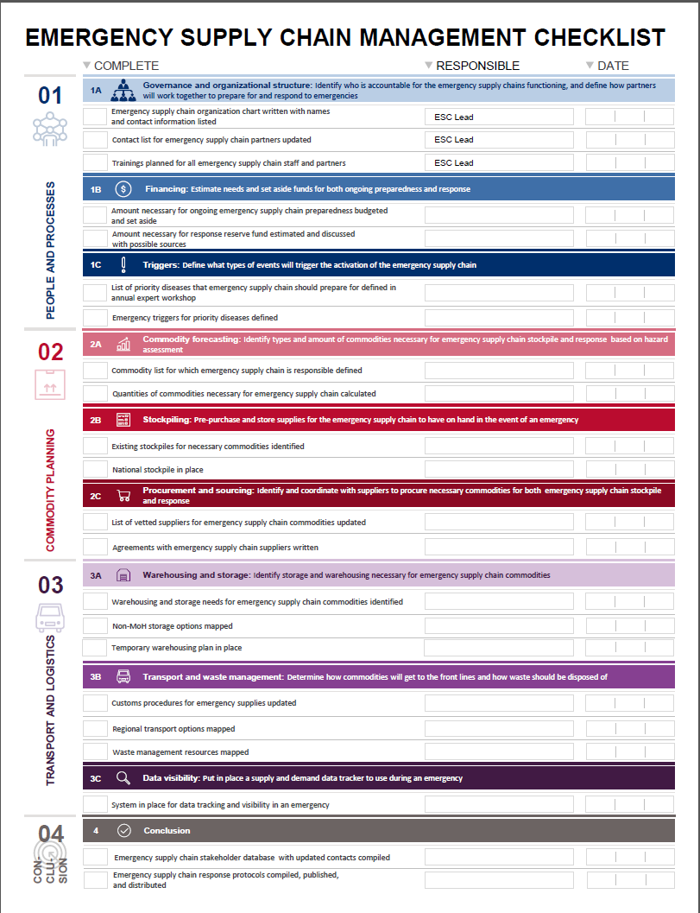
B. Emergency Supply Chain Preparedness Overview | Brief overview of why emergency supply chain preparedness is important and what the work of preparing emergency supply chains entails. Designed for senior leaders to become familiar with ESC Playbook concepts. | 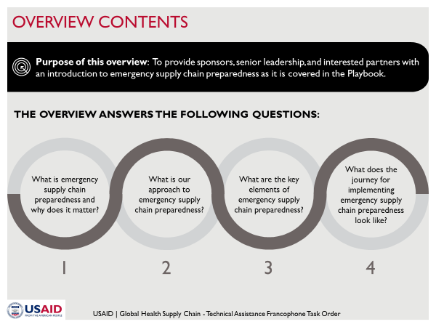
C. Technical User Guide (with Excel Supporting Templates) | Detailed technical instructions and templates (paper and electronic) to assist the core team members in completing the ESC preparedness tasks.  To be used by the ESC core team for implementation and ongoing preparedness maintenance. | 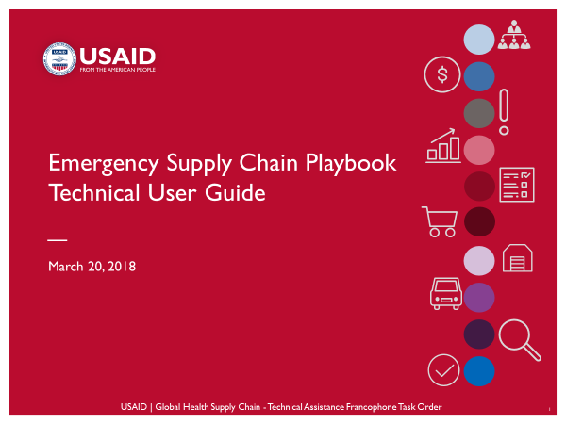
D. Response Disease Job Aids | Disease-specific cards to help ESC managers prepare supply chains at the outset of a disease outbreak. Includes checklist of commodities for each disease, ESC protocols, and contact information. Some aspects will be updated by the core team over the course of working through the ESC preparedness activities.  To be used by all levels of ESC staff during an emergency response effort. | 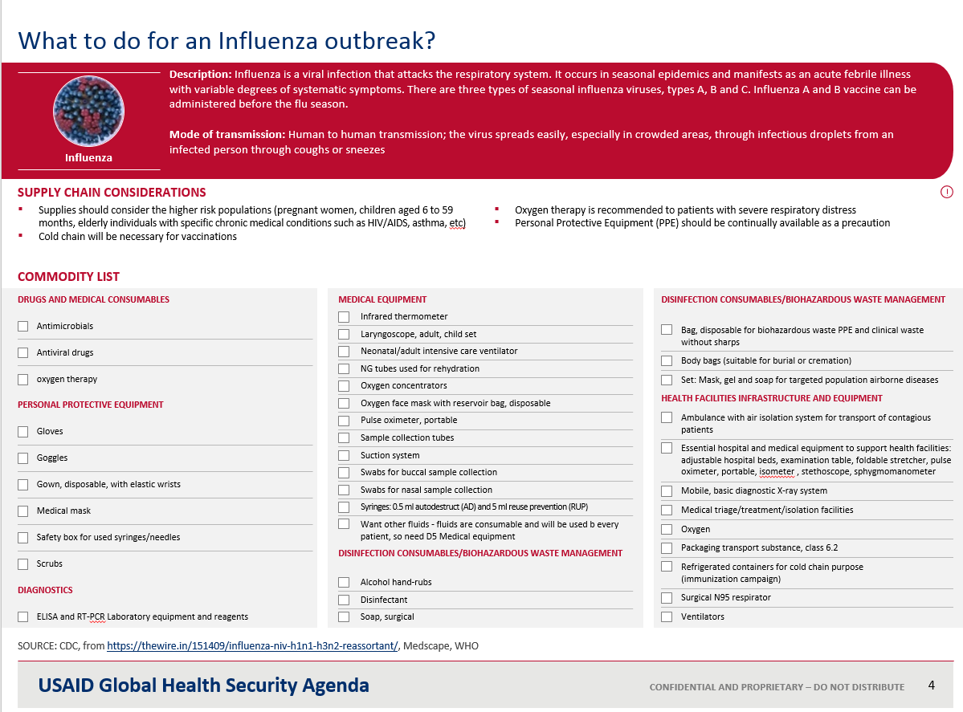
E. Response Quick Guide | Reference for ESC managers on how to respond during an emergency. Some aspects will be updated by the core team over the course of working through the ESC preparedness activities.  To be used by all levels of ESC staff during an emergency response effort. | 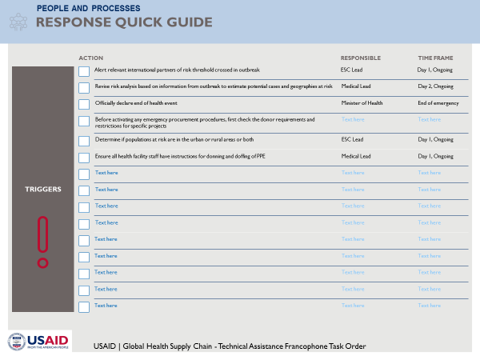

How to get started
The ESC Lead should assemble the core team and convene a planning meeting to:
- Look through the “Getting Started” page of the Technical User Guide and agree on a timeline
- Go through the Management Checklist and assign owners and deadlines
- Set up weekly status meetings for the ESC Lead and core team to update each other on progress
In addition, the ESC Lead should set up a meeting with the senior sponsor for this work and ensure that he/she is aware of the importance of ESC preparedness and has a high-level sense of the work required to achieve it. The Emergency Supply Chain Preparedness Overview might be a helpful item to bring to this meeting.

