Logo of United States Agency for International Development

USAID Global Health Supply Chain Program



ANDREW Ssemugenyi FOR AXIOS INTERNATIONAL, INC.

TECHNICAL ASSISTANCE, NATIONAL SUPPLY CHAIN ASSESSMENT TASK ORDER

Zambia, December 2018

NSCA 2.0

Logos of USAID, Center for disease control and prevention and Department of Health & Human Services

# Acknowledgement

In carrying out this assignment, we have received tremendous support from various sources. First, our appreciation to the United States Agency for International Development (USAID) for providing the funding for this assignment and their guidance and support in ensuring that this assignment was completed without many hitches. Special thanks to the Permanent Secretary of the Ministry of Health (MoH) Zambia, for allowing us unhindered access to the personnel at all levels of the Health System before, during and after data collection. We also appreciate the Chief Pharmacist of the MoH for his personal commitment and for assisting with setting up interviews with Management staff of the MoH. Thanks also to the USAID Global Health Supply Chain - Procurement and Supply Management (GHSC-PSM) Zambia team for their immense support with logistics and data collection, and to all the data collectors for their hard work and dedication as well as all the respondents to this assessment.

**About the Global Health Supply Chain – Technical Assistance Project**

The Global Health Supply Chain – Technical Assistance (GHSC-TA) project serves the health commodity technical assistance needs of USAID, other United States Government agencies, partner country governments, non-governmental organizations and other entities across all health elements (e.g. malaria, and family planning, HIV/AIDS, tuberculosis, and maternal and child health) to meet the evolving challenges in ensuring long-term availability of health commodities in public and private services worldwide. The project also serves to strengthen country supply systems and ensure strategic collaboration to improve the long-term availability of health commodities.

**Brief Description**

The USAID awarded Axios International Inc. (Axios) a task order under the GHSC-TA project in 2016 to update USAID’s National Supply Chain Assessment tool (NSCA). As part of this scope, USAID, in collaboration with Zambia’s MOH, requested that Axios conduct a comprehensive assessment of Zambia’s national supply chain system utilizing the recently updated NSCA tool kit (NSCA 2.0). This report presents the methodology and outcome of that assessment, which was carried out in Zambia in April and May of 2017.

**About Axios**

Axios is a global healthcare organization with over 20 years of experience in the delivery of sustainable and innovative access to care solutions in low and middle-income countries. Axios provides a broad range of services in the global health sector to help modernize and strengthen health systems and quality of care. For more information, visit: <http://axios-group.com/>.

**Recommended Citation**

Axios International, Inc. (2017). Zambia National Supply Chain Assessment Report: Capability and Performance. Submitted to the United States Agency for International Development by Axios International, Inc., under USAID Contract Number: AID-OAA-TO-16-0013 - USAID Global Health Supply Chain – Technical Assistance NSCA Task Order.

**Axios International Inc.**

1050 Connecticut Avenue, 5th Floor

Washington, DC 20036

Phone: 202-772-2031

Fax: 202-772-3101

Web: [www.axios-group.com](http://www.axios-group.com)

# Acronyms and Abbreviations

|  |  |
| --- | --- |
| Acronyms | Abbreviations |
| ACT | Artemisinin-based Combination Therapy |
| AL | Arthemeter Lumefantrine |
| ADR | Adverse Drug Reactions |
| ARV | Anti-retroviral |
| Axios | Axios International Inc. |
| AIDS | Acquired Immune Deficiency Syndrome |
| CMM | Capability Maturity Model |
| CHAZ | Churches Health Association of Zambia |
| DHO | District Health Offices |
| eLMIS | Electronic Logistics Management Information System |
| FP | Family Planning |
| GHSC-PSM | USAID Global Health Supply Chain Program-Procurement and Supply Management |
| GRZ | Government of the Republic of Zambia |
| HC | Health Center |
| HIV | Human Immunodeficiency Virus |
| HR | Human Resources |
| KPI | Key Performance Indicator |
| LMIS | Logistics Management Information System |
| LVL1H | Level 1 Hospitals |
| LVL2/3H | Levels 2 & 3 Hospitals |
| M&E | Monitoring & Evaluation |
| MSL | Medical Stores Limited |
| MOH | Ministry of Health |
| NSCA | National Supply Chain Assessment |
| OTIF | On-Time In-Full |
| PSM | Procurement Supply Chain Management |
| PVG | Pharmacovigilance |
| QPV | Quality and Pharmacovigilance |
| RDT | Rapid Diagnostic Test |
| RFID | Radio Frequency Identification |
| SC | Supply Chain |
| SOP | Standard Operating Procedure |
| RTK | Retroviral Test Kit |
| RHB | Regional Hub |
| SCM | Supply Chain Management |
| SOW | Scope of Work |
| USAID | United States Agency for International Development |
| ZAMRA | Zambia Medicines Regulatory Authority |

# Contents

Acknowledgement 1

Acronyms and Abbreviations 3

Contents 4

Executive Summary 6

Background 7

Health Sector Supply Chain in Zambia 8

Overview of the Supply Chain Assessment 9

Report Overview 9

Methodology 10

Scope of Work 10

The National Supply Chain Assessment Tool Kit 10

Sampling 10

Team Composition and Training 11

Procedures 11

Data Management 14

Results 15

Supply Chain Mapping 15

Overall Results (Summary Tables) 17

Overall Summary of CMM Scores 17

Overall Summary of Select KPIs 19

By Functional Module: Overall CMM and KPI Questionnaire Results 20

Forecasting and Supply Management 20

Summary of Results 21

Discussion 22

Recommendations 22

Procurement 23

Summary of Results 24

Discussion 25

Recommendations 25

Pharmacy and Stores Management 26

Summary of Results 34

Discussion 34

Recommendations 35

Distribution 36

Summary of Results 37

Discussion 37

Recommendations 37

Policy and Governance 39

Summary of Results and Discussion 39

Recommendations 39

Strategic Planning and Management 40

Summary of Results and Discussion 40

Recommendations 40

Quality Assurance and Pharmacovigilance 41

Summary of Results 41

Discussion 41

Recommendations 41

LMIS 43

Summary of Results 44

Discussion 45

Recommendations 45

Human Resources 46

Summary of Results 46

Discussion 46

Recommendations 47

Financial Sustainability 48

Summary of Results and Discussion 48

Recommendations 48

Waste Management 49

Summary of Results 49

Discussion 49

Recommendations 50

By Level of Service: Overall CMM and KPI Results 51

Health Center 51

Summary of Results 52

Discussion 52

Recommendations 52

Level 1 hospitals (LVL1H) (Government and CHAZ) 54

Summary of Results 55

Discussion 55

Recommendations 55

Level 2 & 3 Hospitals (LVL2/3H) (Government) 57

Summary of Results 58

Discussion 58

Recommendations 58

Level 2 & 3 hospitals (LVL2/3H) (CHAZ) 60

Summary of Results 60

Discussion 61

Recommendations 61

Regional hubs (RHBs) 62

Summary of Results and Discussion 62

Recommendations 63

Medical stores limited (MSL) 64

Summary of Results and Discussion 65

Recommendations 65

CHAZ Central Warehouse 66

Summary of Results and Discussion 66

Recommendations 67

MOH and ZAMRA 68

Summary of Results and Discussion 68

Recommendations 69

Advanced Analysis: Relationship between the CMM and KPIs 70

Results of Multivariate Models 72

Discussion of Selected Results—Multivariate Analysis 73

On-Time Delivery 73

Emergency Orders 73

Stock Out on the Day of the Assessment Visit 74

Stepwise Regression Results for the Percent of Tracer Commodities Out-of-Stock on Day of Visit at Health Centers 74

Discussion of Stepwise Regression Results at the Health Center Level 75

Stepwise Regression Model Results at the Hospital Level (Govt and CHAZ) 75

Discussion of Stepwise Regression Results at the Hospital Level 1 (All) 76

Limitations 78

Areas for Further Investigation 79

Summary 81

KPI Findings 81

CMM Findings 82

Conclusions 84

# Executive Summary

The National Supply Chain Assessment (NSCA) was conducted June 14–July 7, 2017, by Axios International Inc. (Axios), Abt Associates, and the United States Agency for International Development (USAID). The assessment was supported by the Government of the Republic of Zambia (GRZ) and Churches Health Association of Zambia (CHAZ) staff throughout the health system to conduct the necessary surveys and data-gathering activities. The NSCA 2.0 tool kit is comprised of three primary elements: supply chain mapping; capability maturity model (CMM) tool covering 11 functional areas; and the results from 14 key performance indicators (KPIs).

The GRZ, CHAZ, and development partners have invested in the supply chain over many years. This assessment sought to identify areas of opportunity and challenges to support the GRZ health goals in coming years. Responses to financial sustainability questions in the CMM indicate that GRZ remains heavily dependent on development partners for funding support, particularly in the cost of commodities.

KPI results and capability maturity scores indicate that many of the key capabilities needed for a high-performing health supply chain exist in Zambia. However, the comparative performance is not consistently achieved throughout the system. In several areas, capabilities were assessed as meeting the more mature, intermediate level, while necessary basic capabilities remain outstanding. Increasing the basic capabilities could mean that facilities or functions can progress rapidly to an intermediate rating. Capabilities and KPIs at the central level are generally stronger than in patient-facing health facilities (hospitals and health centers [HCs]).

**Table 1.**

**NSCA 2.0 CMM Functional Areas**

* Forecasting & Supply Management
* Procurement
* Pharmacy & Stores Management
* Distribution
* Policy & Governance
* Strategic Planning & Management
* Quality & Pharmacovigilance
* Logistics Management Information Systems
* Human Resources
* Financial Sustainability
* Waste Management

Stock outs of one or more tracer commodities were reported across the system at HCs and hospitals in the six months prior to the assessment. In 15% of HCs, the main first-line Anti-retroviral (ARV) was stocked out on the day of the assessors visit, and around 17% showed a stock out of the first-line antimalarial (Artemether-Lumefantrine (AL), specifically the 6x4 presentation. Adherence to supply plans and results for the stocked according to plan and stock card accuracy KPIs were low at all facilities, which was no doubt contributing to the incidence of stock outs. Medical Stores Limited (MSL) and CHAZ central warehouses had stocks (i.e., no stock outs) of tracer commodities on the day of the assessor’s visit. However, many orders placed on MSL by facilities were adjusted, with the reasons given as adjusted due to stock out, or limited stock.

The recently introduced eLMIS system was a positive indicator in the supply chain (it was performing well where there was internet connectivity) and correlated to stronger performance in stock management, fewer emergency orders, and lower levels of stock out. Costs of storage, distribution, and wastage levels were below international norms. The newly introduced regional distribution hubs also showed potential to improve stock levels, and timely delivery to health facilities.

There is a commitment throughout the health system to serve patients. This NSCA indicates potential to further improve service levels by the regional hubs (RHBs) and eLMIS innovations and by greater use of existing tools such as forecasting and supply planning, timely distribution, and stores management.

# Background

Zambia is a lower-middle-income country located in the central-southern region of Africa. The estimated population was 16.2 million in 2015,[1] with a growth rate of 3% per annum. Zambia is divided into 10 administrative provinces and 105 districts. The GRZ has established long-term development goals articulated in the National Vision 2030 document, which seeks to raise the country to a middle-income prosperous nation by 2030.[2]

The Ministry of Health (MOH) in Zambia is responsible for providing strategic direction, setting policies, and allocating funding for the health sector. To support the vision of a nation of healthy and productive people, the MOH developed several guiding principles that include ensuring equitable access to health care for the people of Zambia, regardless of their geographical location, gender, age, race, social, economic, cultural, or political status.[3] The National Health Policy of 2012 provides guidance to develop the health sector and prioritizes primary health care services, hospital referral services, human resource development and management, medical supplies and logistics, infrastructure development, legal framework, and health care financing.[4] The Zambia National Health Strategic Plan 2017–2021 provides further strategic direction with an emphasis on health promotion, disease prevention, and curative and rehabilitative services in close-to-the-client settings.[5]

Health service delivery in Zambia is designed to provide services as close to the community level as possible with a primary care approach. Health services are provided through government facilities, faith-based facilities under the coordination of CHAZ, the mines, and privately-owned health facilities. The MOH services are largely financed from public tax, donor communities, and direct payments by households.[6]

## Health Sector Supply Chain in Zambia

The National Medicines Policy and Public Health Act of Zambia provides the policy, legislative, and regulatory frameworks for the health sector supply chain through the Medicines and Allied Substances Act (3) 2013. It established the Zambia Medicines Regulatory Authority (ZAMRA) to regulate and control the manufacturing, importation, storage distribution, supply, sale, and use of medicines and allied substances.

The Health Sector Supply Chain Strategy and Implementation Plan (2015–2017) articulates the current successes and challenges within Zambia’s health supply chain system and proposes ways to strengthen forecasting and quantification, procurement, coordination, and distribution of medicines and medical supplies. The vision is to provide equitable access to affordable, quality, essential medicines and medical supplies to support Zambia’s public health system. The GRZ has expressed concern about the health sector procurement and supply chain system in supplying its citizens with quality medicines when and where they need them. Though multiple efforts have been implemented to improve the supply chain system over the past several years, gaps remain. Current concerns include irregular post-marketing surveillance on all medicines and weak enforcement of standards of practice, leading to irrational and ineffective use of medicines. Further challenges include inadequate specialized equipment and human resources capacity.[7]

The MSL is a parastatal company, established under the Companies Act, with a mandate that includes the distribution of health commodities to all hospitals and HCs down to the last mile; procurement of essential medicines and medical supplies, and the coordination of commodity quantification activities. Significant investments have been made to upgrade MSL infrastructure to ensure commodity security in the country. The MOH has initiated the transfer of the procurement functions from the MOH to MSL with the goal of improving the effectiveness of procurement services. However, MSL faces current challenges related to an inadequate fleet of vehicles and insufficient storage space at the central and provincial levels.[8]

## Overview of the Supply Chain Assessment

This assessment was conducted in-country from June 14 to July 7, 2017, by Axios at the request of the United States Agency for International Development (USAID) and the MOH in Zambia with the aim of providing results that facilitate the development of goals and specific objectives to strengthen the health supply chain in Zambia. To this end, the assessment examined the capability and performance of the public health supply chain system, utilizing the newly updated NSCA 2.0 tool kit. The tool kit is designed to identify the capacity of the supply chain at various levels by mapping and measuring supply chain capability maturity and to measure performance against KPIs. The primary objectives of this assessment were as follows:

* Measure the performance and capability of the public health supply chain.
* Analyze the overall operational capacity and performance of the public health supply chain, identifying bottlenecks and opportunities for improvement.
* Identify the performance and any gaps to guide Zambia’s and donors’ investments to strengthen the supply chain.
* Provide the Government of Zambia with information to initiate strategic planning, and to implement system strengthening initiatives that can contribute towards a well-performing supply chain.

# Report Overview

This report provides an overview of the NCSA 2.0 assessment implemented in Zambia including the results of the assessment activities. Assessment results will be described in three key segments: 1) health supply chain mapping, 2) CMM, and KPI scores presented by both functional module and level of service (e.g., health center, district hospital), and 3) a set of regression analyses exploring potential correlations between the CMM scores and KPI performance. The discussion is focused on providing interpretations of the results and translating these points into recommendations for future supply chain management activities. The summary and conclusion draw out key takeaways and propose future areas for investigation. The Report Annexes, contained in a second volume, provide complete assessment tools, results, analysis, and other detailed information.

# Methodology

This section describes the methodology used to conduct the NSCA in Zambia. The assessment methodology drew on the revised NSCA 2.0 tool and a series of meetings with relevant in-country stakeholders to define the Scope of Work (SOW) and reflect the national context. This approach also enabled partner buy in. The NSCA 2.0 tool kit was used to guide data collection, storage, and analysis.

## Scope of Work

The SOW required that the assessment team conduct a comprehensive assessment of the Zambia national supply chain system at three levels: the central level; the district level (intermediate); and the peripheral level (HCs). This assessment required mapping the health supply chain structure, assessing the capability maturity, and measuring performance against KPIs. The assessment was conducted at 45 HCs, 27 hospitals, 4 RHBs, MSL, the MOH (including ZAMRA), and CHAZ during June and July 2017.

## The National Supply Chain Assessment Tool Kit

The NSCA 2.0 is an updated tool kit that measures the capability, functionality, and performance of supply chain functions at all levels of a national health supply chain system. The tool kit is comprised of three primary elements: supply chain mapping; the CMM tool; and the KPI assessment tool.

**Table 2. Description of key elements of the NCSA 2.0 tool kit**

|  |  |
| --- | --- |
| Activity | Description |
| Supply chain mapping | The objective of mapping the health supply chain is to obtain an in-depth understanding of the health supply chain, including the role and responsibilities of the key actors in the supply chain. |
| CMM tool | The CMM diagnostic tool assesses capability and processes across functional areas and cross-cutting enablers (HR, financial sustainability, etc.) using interviews and direct observation. |
| Supply chain KPIs | The KPIs include a set of indicators that measure supply chain performance in selected functional areas. |

## Sampling

The sample size was determined using the hypergeometric sample size formula, assuming a margin of error of ±10% and an 85% level of confidence (i.e., α=0.15). A two-stage sampling process was employed with selection of central facilities and CHAZ and Level 2 & 3 (LVL2/3H) hospitals done separately. The sample size was initially calculated for the number of districts and later calculated for the number of HCs needed based on the above parameters. Districts were selected with the probability of inclusion in the assessment proportional to the number of HCs in each district. Within each district, one Level 1 (LVL1H) hospital was selected if one existed in a selected district. For districts with more than one LVL1H hospital, the hospital included in the assessment was selected at random. In each district, two Health Centers (HCs) were selected at random. For (LVL2/3H) hospitals and for CHAZ hospitals, the calculations were set to have a level of confidence (α) of 0.20 and a margin of error of ±15%. The four RHBs, MSL, CHAZ central warehouse, and the MOH (including ZAMRA) were also included.

Using these criteria, 22 districts were selected for inclusion in the sample, indicating that 44 HCs were included. Eighteen LVL1H hospitals were initially included (with four districts not having a hospital); after visiting the sites, one site selected as a LVL1H hospital was determined to have been a health center. Thus, 17 LVL1H hospitals and 45 HCs are included in the final sample, along with 10 (LVL2/3H) hospitals, including the three central level institutions and the four RHBs. A total of 79 sites were included in this assessment.

## Team Composition and Training

Central data collection and field teams were constituted for this assessment. The central team was comprised of members of the Axios team, USAID advisors, and a master’s degree student. Ten field teams of two or three individuals each were identified to implement the assessment and collect data. The field teams were composed of provincial pharmacists, masters’ degree students, one GHSC-PSM/Zambia staff member, and Axios staff. The participation of local supply chain actors from different levels of the supply chain ensured access to key informants and data sources while also promoting local ownership of and buy in for the assessment. Prior to initiating primary data collection activities, all data collectors attended a five-day data collection training. The MOH staff were not sent to their home districts to help mitigate any potential risk of bias in the results.

## Procedures

The central team collected data from the MSL, CHAZ, ZAMRA and the MOH for items in both the CMM and KPI questionnaires. The field teams collected data from HCs, level 1, 2 and 3 hospitals, and the new RHBs.

A capability questionnaire was completed by interviewing the person at each site best situated to respond to each module based on the respondents’ area of operation (i.e., stock manager and/or health facility manager). As part of that tool, both documentation confirmation (e.g., logistics reports, requisitions forms) and observations (e.g., store room) were captured. Data were collected electronically using the SurveyCTO platform on tablet computers. Table 3 provides an overview of which functional areas were addressed in the capability questionnaire by type of facility.

Annex 7 provides a map of the geographic coverage of sites assessed, and Annex 6 provides a complete list of the facilities assessed.

**Table 3. CMM functional area by level in the Zambian supply chain system**

|  |  |  |  |  |  |  |  |  |
| --- | --- | --- | --- | --- | --- | --- | --- | --- |
| # | Functional modules assessed | MOH/ ZAMRA | MSL | CHAZ | RHBs | LVL2/3Hs | LVL1Hs | HCs |
| 1 | Strategic planning and management | √ | √ | ** |  | √ |  |  |
| 2 | Human resources* | √ | √ | √ | √ | √ | √ | √ |
| 3 | Financial sustainability* | √ | √ | √ |  | √ | √ | √ |
| 4 | Policy and governance* | √ | √ | ** |  |  |  |  |
| 5 | Quality and pharmacovigilance (QPV)* | √ | √ | √ | √ | √ | √ | √ |
| 6 | Forecasting and supply planning | √ |  | √ |  | √ |  |  |
| 7 | Procurement and customs clearance | √ |  | √ |  | √ |  |  |
| 8 | Pharmacy and stores management | √ | √ | √ | √ | √ | √ | √ |
| 9 | Distribution | √ | √ | √ | √ | √ | √ | √ |
| 10 | Logistics management information systems | √ | √ | √ | √ | √ | √ | √ |
| 11 | Waste management | √ | √ | √ | √ | √ | √ | √ |

*Includes ZAMRA

**These data should have been collected for the assessment, but the team was not able to collect this data

The data collection team also used a KPI assessment tool to collect quantitative data for a core set of KPIs that are in alignment with international standards for health supply chain management, as shown in table 4 below. Ten tracer commodities (see table 5) were identified as representative of key requirements by local stakeholders and were used for appropriate KPIs (e.g., stock data). Data were collected electronically using the SurveyCTO platform on tablet computers.

**Table 4. KPIs by the level in the Zambia supply chain**

|  |  |  |  |  |  |  |
| --- | --- | --- | --- | --- | --- | --- |
| # | KPI | MSL | CHAZ | LVL2/3Hs | LVL1Hs | HCs |
| 1 | Stocked according to plan | √ | √ | √ | √ | √ |
| 2 | Stock out rate by tracer commodity by level in the system | √ | √ | √ | √ | √ |
| 3 | Stock accuracy | √ | √ | √ | √ | √ |
| 4 | On-time delivery to facility | √ | √ |  |  |  |
| 5 | Staff turnover rate | √ | √ | √ | √ | √ |
| 6 | Stock turn per annum | √ | √ |  |  |  |
| 7 | Facility reporting rates on time | √ | √ |  |  |  |
| 8 | Order fill rate | √ |  |  |  |  |
| 9 | Number and duration of temperature excursions in cold storage facility | √ |  | √ | √ | √ |
| 10 | Forecast accuracy | √ |  |  |  |  |
| 11 | Supply plan accuracy | √ |  |  |  |  |
| 12 | Vendor on-time and in-full delivery rate | √ |  |  |  |  |
| 13 | Source of funds data | √ |  |  |  |  |
| 14 | Percent of international reference price paid | √ |  |  |  |  |
| 15 | Percentage of incoming batches tested for quality | √ |  |  |  |  |
| 16 | Percentage of product batches tested that meet quality standards | √ |  |  |  |  |
| 17 | Cost of distribution operation | √ |  |  |  |  |

Data sources included stock cards, LMIS and eLMIS reports, pro formas, orders, proof of delivery notes, temperature excursion data, and dispatch notes. Some of the documentation data were retrospectively collected for the six months prior to the assessment, while other data were collected retrospectively for the year (e.g., MOH, MSL, and CHAZ).

Please refer to Annex 4 for the full NSCA 2.0 KPI tool kit used during the Zambia assessment, including the data sources. The complete KPI data analysis results are available in Annex 5.

**Table 5. Tracer commodities identified by Zambia’s MOH in collaboration with USAID**

|  |  |  |  |
| --- | --- | --- | --- |
|  | Product name | Strength/Dosage | Product category |
| 1 | Amoxicillin capsule | 250mg | Essential drug |
| 2 | Artemether-Lumefantrine (AL) (Coartem) 6x4* | 20/120mg | Antimalarial |
| 3 | Depo Provera | Injection | Family planning |
| 4 | Determine- Rapid Test Kit (RTK) | Test | Laboratory |
| 5 | Oxytocin injection | 10ui/ml | Emergency obstetrical care |
| 6 | Tenofovir+Lamivudine+Efavirenz (TDF+3TC+EFV) | 300mg+300mg+600mg | ARV |
| 7 | Abacavir+Lamivudine (ABC+3TC) | 60/30mg | Pediatric ARV |
| 8 | Oral Rehydration Solution (ORS ) | Sachet | Essential drug |
| 9 | Paracetamol | 500 mg tablet | Essential drug |
| 10 | Rapid Diagnostic Test (RDTs) for malaria | Test | Laboratory |

*Stock data were also collected on Artemether-Lumefantrine (AL) (Coartem) 6x1, 6x2, and 6x3.

## Data Management

All completed CMM and KPI questionnaires were uploaded to the SurveyCTO secure data server daily. Data were reviewed daily, and data collection teams were contacted to clarify discrepancies in or questions related to the uploaded data.

# Results

The supply chain map is presented first to show the flow of products and information, followed by an overview table of CMM results and a summary of the 14 KPI results. Results and findings are then detailed for each functional area and then for each level of service. For each of the 11 functional areas included in the CMM questionnaire, results are presented as follows: 1) CMM score broken down by level of maturity, 2) key capability achievements, and 3) key capability gaps. It is important to note that key capabilities and gaps are specifically discussed only in cases where they convey meaningful information. For the pharmacy and stores management, distribution, logistics management information system, and human resource modules, relevant KPI metrics have been included. Discussion and recommendations specific to the function or service level follow the presentation of findings. Recognizing the importance of system effects, regression results and a discussion of correlations and interdependencies follows.

## Supply Chain Mapping

The supply chain was mapped to obtain an in-depth understanding of its structure, the flow of information and commodities, and the role and responsibilities of the key actors. This activity included gathering information on the components of the supply chain and how they are interconnected. See Figure 1 for the completed map.

Points to note from the map are that the RHBs were a new feature that was still being rolled out nationwide at the time of the assessment. Therefore, it was not possible to fully assess the impact of the new structure and how these RHBs may affect other actors in the national health supply chain once they are fully established. For the purpose of this assessment, ZAMRA was considered as part of the central MOH organization; ZAMRA is responsible for drug registration, quality assurance, and pharmacovigilance. Zambia operates district health offices (DHO) located close to one or more health facilities that serve as the extension of the pharmacy store for those health facilities, especially where there are space constraints. Vaccines and TB drugs are also distributed via the DHOs.

No data could be collected at the DHOs as they are not usually accountable for the commodities kept there, and inventory management tools or records are not kept by the DHOs. The commodities are delivered by the MSL packed per facility, and they are left at the DHO for collection by or delivery to the facility when needed. CHAZ is an autonomous, independent faith-based operation responsible for its own procurement, although it does receive donations of ARVs, malaria, and possibly Family Planning (FP) commodities from donors.

**Figure 1. Flow of commodities and information between supply chain organizational entities**

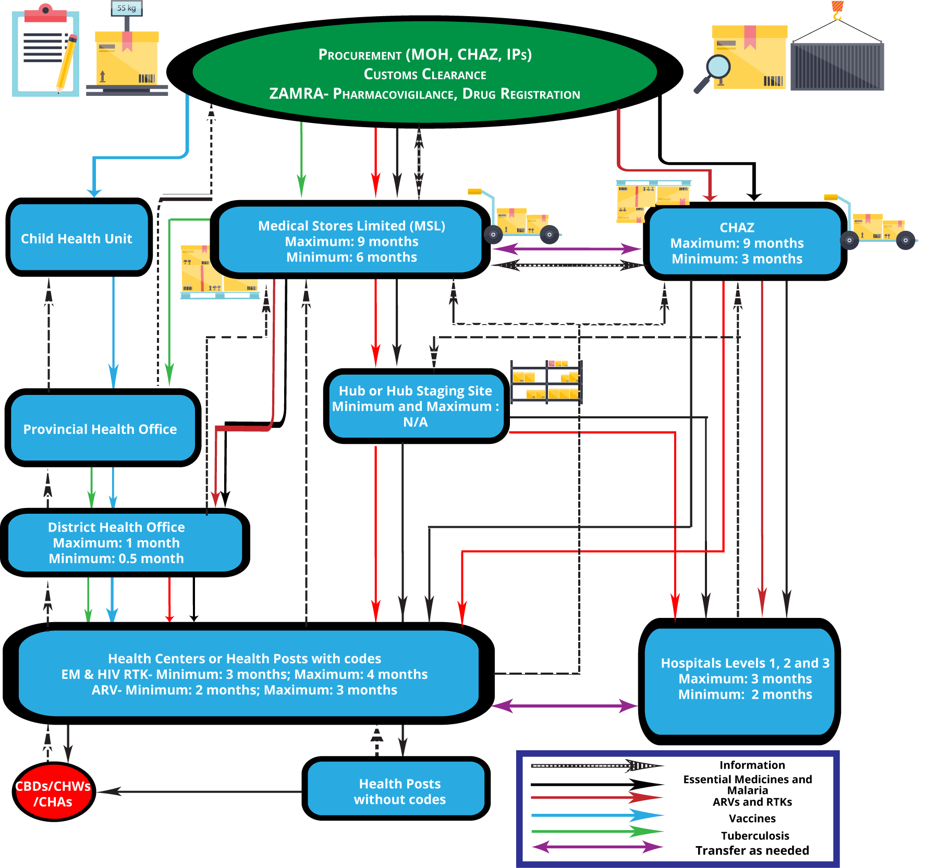

## Overall Results (Summary Tables)

When reviewing the CMM results presented below, it is important to consider how the scoring was completed. The capability and processes were assessed based on a maturity model, adapted from private-sector best practices to fit the public health context. Results from the CMM and KPIs are presented overall, by functional area and by level of service delivery.

Within each functional area, the overall CMM questionnaire score is a composite score derived from results on four levels of maturity/achievement (as shown in Table 6 below). Out of a total possible 100% CMM score, each level comprised varying portions of the 100%. For example, functional capability required for basic services contributed a maximum of 50% of the overall CMM score.

**Table 6. Description of levels of achievement that comprise the overall CMM score**

|  |  |  |
| --- | --- | --- |
| Level of maturity | Definition | Maximum contribution to the CMM score |
| Basic | These are the must-have policies, structures, processes, procedures, tools, indicators, reports, and resources to operate a supply chain system (e.g., a stock record—paper or electronic—as a tool for inventory management). | 50% |
| Intermediate | These are not must-haves but are should-have policies, structures, processes, procedures, tools, indicators (e.g., an Excel sheet). | 30% |
| Advanced | These are nice-to-have policies, structures, processes, procedures, tools, indicators, reports, and resources to operate a supply chain system (e.g., Rx solution, a dispensing and stock management electronic tool). | 15% |
| State of the art | These are non-essential, state-of-the-art policies, structures, processes, procedures, tools, indicators, reports, and resources for a supply chain system (e.g., an enterprise resource planning system for stock management and control). | 5% |

For different functions, any given facility may have varying levels of maturity. For example, a facility’s warehouse and stores operations may be operating at an intermediate or advanced maturity level, while distribution is still evolving toward basic maturity. The components that make up the basic level are scored separately from those components associated with the intermediate level; the scoring is done this way in order to recognize that even within a function, there may be a mix of maturity levels. The overall score for a single function is a composite of all basic, intermediate, advanced, and state-of-the-art scores. As such, it is important to consider that an overall maturity score of intermediate does not necessarily indicate that every aspect of that function has achieved that level of maturity.

The results and discussion section discusses specific basic CMM indicators for a function or level of service. If more than 80% of facilities responded positively, it is noted as an achievement. If the response was negative to a CMM indicator, it is noted as a significant gap. Annex 6 provides a full list of facilities that responded with more than 80% for a capability achievement or less than 20% for a capability gap on the basic CMM indicators.

## Overall Summary of CMM Scores

A summary table of CMM scores is presented in Table 7 below.

**Table 7. Average CMM score and range of scores presented by level of facility for each functional module**

|  |  |  |  |  |  |  |  |  |  |
| --- | --- | --- | --- | --- | --- | --- | --- | --- | --- |
| Module | HC | Hospital L1 | Hospital L2/3  (Govt) | Hospital L2/3 (CHAZ) | Regional hubs | MSL | MOH | ZAMRA | Central warehouse (CHAZ) |
|  | n = 45 | n = 17 | n =6 | n = 1 | n = 4 | n= 1 | n = 1 | n=1 | n = 1 |
| Forecasting and supply planning | - | - | 65% (45-58) | 38% | - | - | 67% | - | 48% |
| Procurement | - | - | 67% (42-73) | 52% | - | - | 95% | - | 62% |
| Pharmacy and store management | 38%  (21–56) | 52%  (43–71) | 61%  (54–74) | 55% | 47%  (36-57) | 58% | 74% | - | 58% |
| Distribution | 33%  (0–54) | 45%  (17–54) | 69%  (69–69) | 51% | 63%  (40–74) | 69% | 43% | - | 71% |
| Policy and governance | - | - | - | - | - | 14% | 60% | 83% | -* |
| Strategic planning and management | - | - | 47%  (0–88) | 28% | - | 46% | 77% | - | -* |
| Quality assurance and pharmacovigilance | 18%  (0–70) | 42%  (11–75) | 57%  (15–95) | 15% | 17%  (3–41) | 50% | - | 86% | 69% |
| Logistics management information systems | 39%  (0–90) | 68%  (39–92) | 66%  (52–77) | 49% | 26%  (9–51) | 46% | 38% | - | 48% |
| Human resources | 37%  (7–70) | 46%  (25–88) | 57%  (23–74) | 56% | 44%  (32–56) | 53% | 84% | 85% | 33% |
| Financial sustainability | 36%  (0–75) | 52%  (25–75) | 58%  (47–73) | 53% | - | 50% | 59% | 52% | 30% |
| Waste management | 26%  (0–63) | 35%  (0–75) | 56%  (19–83) | 41% | 17%  (0–47) | 54% | 80% | - | 74% |

*These data should have been collected for the assessment, but the team was not able to collect this data.

In addition to noting the average performance by function and facility, it is important to note the range of scores recorded. This range indicates the variation in performance across the facilities at a service level. The table illustrates functions where capability scores are low across the system, indicating that a more systemic or strategic approach is required.

## Overall Summary of Select KPIs

A summary table of selected KPIs is presented in Table 8 below.

**Table 8. Summary table of selected KPIs across levels of service**

|  |  |  |  |  |  |  |  |  |
| --- | --- | --- | --- | --- | --- | --- | --- | --- |
| Indicator | HC | Hospital L1 | Hospital L2/3  (Govt) | Hospital L2/3 (CHAZ) | Regional hubs | MSL | MOH | Central warehouse (CHAZ) |
|  | n = 45 | n = 17 | n =6 | n = 1 | n = 4 | n = 1 | n = 1 | n = 1 |
| # of emergency orders (emergency orders as % of all orders) | 1% | 10% | 37% | 30% | - | - | - | - |
| Stocked-according-to-plan (tracer commodities) | 20% (16–24) | 14% (6–32) | 18% (4–31) | 15% (6–28) | - | 13%  (0 – 60) | - | 53% (17 –100) |
| Stock out on day of assessment | 12% | 6% | 15% | 3% | - | 0% | - | 0% |
| % of days out of stock in previous six months** | 8% | 8.3% | 10% | 3.9% | - | - | - | 5.9% |
| Average number of days per month with stock outs, given that there was a stock out | 12.6 | 14 | 16.4 | 16.8 | - | - | - | 13.5 |
| % of routine orders delivered on or before promised delivery date | 33% | 35% | 56% | 27% | 50% | 50% | - | - |
| % of routine orders delivered within two days of promised delivery date | 67% | 23% | 11% | 27% | 15% | 8% | - | - |
| % of emergency orders delivered on or before promised delivery date | - | - | 0% | 0% | - | - | - | - |
| % of emergency orders delivered within 2 days of promised delivery date | - | - | 0% | 100% | - | - | - | - |
| eLMIS updated in last seven days | 48% | 34% | 22% | 63% | - | 100% | - | - |
| Stock accuracy (eLMIS) | 32% | 23% | 11% | 33% | - | 0% | - | 40% |

** There were 182 days in this period. The reported number is the percentage of days the commodity was out of stock, an average across tracer commodities.

## By Functional Module: Overall CMM and KPI Questionnaire Results

The following presents the key results from the assessment of the 11 functions. Results of the CMM scores are presented by level and followed by KPIs (where applicable). It is important to note that key capabilities and gaps are specifically discussed only in cases where they convey meaningful information. The full set of data results is available for reference in Annexes 3, 5, and 8.

### Forecasting and Supply Management

**Figure 2. Forecasting and supply planning CMM score per level of achievement by level**

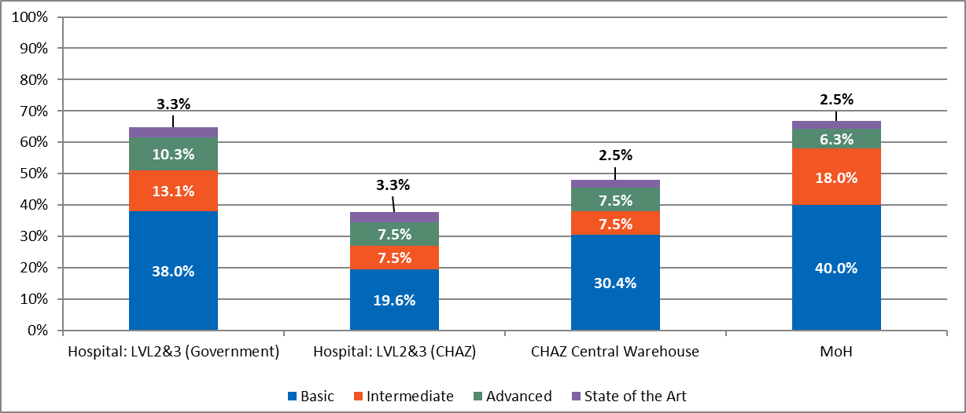

Maximum score for Basic is 50%; for Intermediate, 30%; for Advanced, 15%; for State of the Art, 5%. For instance, if the Basic portion is actually 45%, it should be interpreted as 45/50.

**Figure 3. Forecast and supply plan accuracy per tracer product**

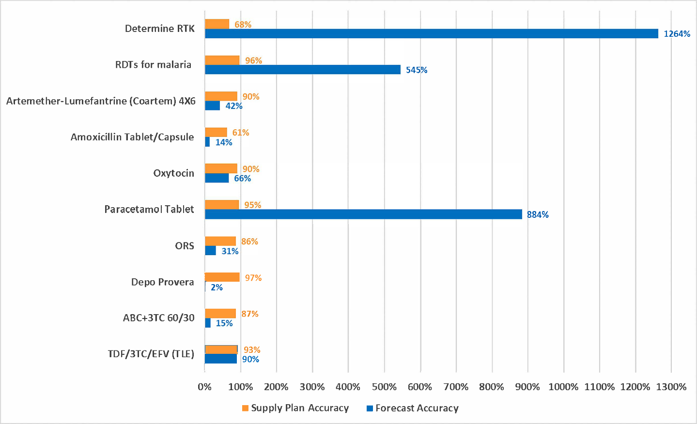

**Table 9. Forecasting and supply planning—Select key capability gaps**

|  |  |  |
| --- | --- | --- |
| Indicators for LVL2/3H government hospitals | % achieved | Possible solutions |
| Capacity building in forecasting and quantification | 16% | Identify capacity gaps and institute targeted training to bridge gaps within government hospital and CHAZ |
| Forecasting methodology, data sources, and assumption documentation | 17% | Introduce systems and processes to improve documentation on methodology, data sources and assumptions. These documents should be readily available. |

Summary of Results

Forecasting is only completed at the following levels of service: government hospital (LVL2/3H), CHAZ hospital (LVL2/3H), CHAZ central warehouse, and MOH; as a result, these are the only levels of service discussed in this section. Across all levels of service engaged in forecasting, none of the facilities reached an overall greater score than 69% of the total, nor did any of the facilities attain the maximum possible score within the intermediate, advanced, and state-of-the-art maturity levels. Specifically, the maturity scores for forecasting and supply planning for MOH and government hospitals were at 67% and 65%, respectively. At the basic level, the maturity scores were strong (attainment of about 80% of the overall basic score of 50%) with little difference between MOH and government hospitals at 40% and 38%, respectively. In contrast, CHAZ central warehouse and LVL2/3H hospitals had lower scores for the basic level (30% and 20%, respectively).

Key capability gaps suggest weaknesses were observed related to inadequate capacity building in forecasting and quantification as well as documentation of methodology, data sources, and assumptions.

At the MOH level, consumption data was assessed and used to inform procurement. The government hospitals (LVL2/3H) were particularly strong at assessing the quality of consumption data used for forecasting and utilizing the data to inform procurement. The MOH is responsible for supply planning. The supply plan accuracy from records obtained from MSL for the 10 selected tracer commodities ranged from 61% to 97%. Forecasting accuracy for the 10 selected tracer commodities varied widely from 2% to 1,264%.

Discussion

The maturity observed at the basic level suggests that Zambia has the foundation required to generate and execute forecasts and supply plans at the MOH and government hospital levels. The imbalance in forecasting capabilities between CHAZ and MOH health facilities is evident from the maturity scores. The forecasting process is impacted by gaps observed in staff capacity in documenting forecasting methodologies, data sources, and assumptions. Improvements in these areas could result in improved prediction of stock needs and procurement. Despite the strong supply plan accuracy (61%-97%) for the 10 selected indicator commodities at the time of the assessment, MSL had no internal system of assessing its supply planning performance using the supply planning KPI. This situation is a potential operational risk as bottlenecks and stock inaccuracies may not be detected in time resulting in delays in programmatic interventions might be delayed or may not happen at all. The wide variability in forecasting accuracy observed is underscored by poor data quality in the forecasting process. The observed percentages of eLMIS data updated in the last seven days (HC 48%, hospitals LVL1H 34%, and Hospital LVL 2 22%) together with stock accuracy (HC 32%, Hospitals LVL1H 34%, and Hospital LVL 2 11%) appear to support this observation. Strengthening data quality can improve forecast accuracy and preclude downstream supply chain issues related to meeting the needs of those at the last mile.

Recommendations

MSL should track supply planning accuracy to prevent supply disruptions.

Capacity building for forecasting and supply planning as well as the use and application of KPIS for supply planning should be strengthened. MOH should set up system that promotes the exchange of knowledge, skills, and capacity building interventions with CHAZ.

Guidelines for forecasting and supply planning should be developed to ensure a sustainable process.

HCs and hospitals should be supported to improve data quality through training, support supervision, and data quality reviews.

### Procurement

**Figure 4. Procurement CMM score per level of achievement by level**

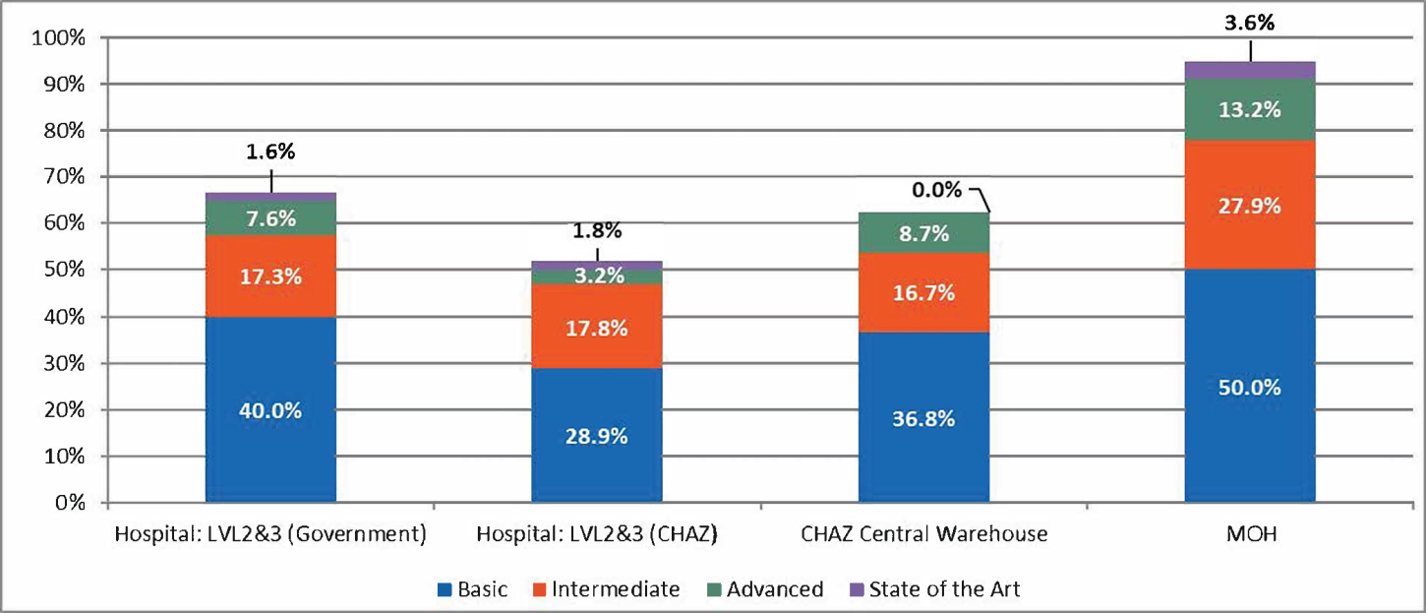

Maximum score for Basic is 50%; for Intermediate, 30%; for Advanced, 15%; for State of the Art, 5%. For instance, if the Basic portion is actually 45%, it should be interpreted as 45/50.

**Table 10. Procurement–Select key capability achievements**

|  |  |
| --- | --- |
| Indicators for MOH | % achieved |
| Essential medicines, medical and laboratory supplied list used by MOH for procurement | 100%–MOH |
| Indicators for MSL | % achieved |
| On-time, in-full delivery rates for items procured by MSL | 95% on-time, 100% in-full |

**Table 11. procurement– Select Key Capability Gaps**

|  |  |  |
| --- | --- | --- |
| Indicators for LVL2/3H government and CHAZ hospitals | % achieved | Possible solutions |
| Availability of standard operating procedures (SOP) for procurement | 0%–CHAZ  50%–MOH | Determine specific reasons for widespread unavailability of SOP and address them |

**Table 12. Procurement–KPI (MSL)**

|  |  |  |  |
| --- | --- | --- | --- |
| Indicator | Routine orders |  |  |
|  | Number of orders sampled | Number of orders with full data | Percentage delivered on or before the promised delivery date |
| Vendor on-time and in-full delivery | 20 | 20 | 95% |
|  | Percentage of orders |  |  |
| In-full delivery | 100% |  |  |
| On-time and in-full delivery | 95% |  |  |
| Percentage of orders placed as emergency orders | 1.3% |  |  |
|  | Percentage of international reference price paid |  |  |
| TDF/3TC/EFV (TLE)- 300mg+300mg+600Mg | 105% |  |  |
| ABC+3TC-30/60mg | - |  |  |
| Depo Provera-Vial | - |  |  |
| ORS-Satchet | 182% |  |  |
| Paracetamol tablet-500mg | 134% |  |  |
| Oxytocin-10iu/ml | 95% |  |  |
| Amoxicillin tablet/capsule-250 mg | 148% |  |  |
| Artemether-Lumefantrine (Coartem) 6x4- 20/120mg | 50% |  |  |
| RDTs for malaria-test | - |  |  |
| Determine RTK-test | - |  |  |

Summary of Results

The overall maturity scores for procurement are strong at the MOH compared to the government hospitals LVL2/3H at 95% and 67% respectively. Basic maturity scores are strong for both the MOH (50%) and the government hospitals (40%). Procurement at the MOH is done based on the essential medicines lists, medical, and lab supplies list. However, weaknesses in internal procurement audits were noted in both government and CHAZ facilities. In addition, standard operating procedures for procurement were absent at all CHAZ facilities and in half of the government hospitals. Government contributions to the procurement budget were reported at 25%. As indicated in the table above, in-full and on-time delivery rates at MSL for a sample of 20 orders was 100% and 95%, respectively. On the other hand, the percentage of international reference price paid ranged from 50% to 182% (average 119%). The percentage of orders placed as emergency orders was 1.3%.

Discussion

The overall maturity scores for procurement at MOH are consistently advanced. However, these should be supported by reliable forecasts and efficient/rational pricing mechanisms. CHAZ facilities performed well in the intermediate range. However, they are not at par with their MOH counterparts. The partial or total absence of SOPs at the various procurement levels introduced variations in the procurement process. Lack of availability and use of SOPs creates a situation of non-standardization of procurement processes and workflows leading to potential inefficiencies within the system, potential procurement bottlenecks, and possible overdependence on development partners for procurement related activities. The absence of internal procurement audits pose a risk to accountability, transparency, and value for money. The performance against selected procurement indicators point toward satisfactory supplier performance management and good supply planning. On the other hand, analysis of Zambia procurement prices reflects a maximum percentage that is nearly twice the median prices paid in the international settings for some tracer products. The wide variations in prices of tracer commodities suggests lack of control of prices through benchmarking, negotiations, and competition.

Recommendations

* MOH should introduce additional controls such as internal procurement audits to reduce risks associated with the process (e.g., transparency, accountability, and value for money).
* Standard operating procedures should be developed and made available at all levels of procurement, and procurement staff should be trained and monitored through internal audits on use and compliance.
* Value-for-money analysis coupled with benchmarking and price negotiations should be strengthened to obtain savings that can be used to buy additional commodities.

### Pharmacy and Stores Management

**Figure 5. Pharmacy and stores management CMM score per level of achievement by level**

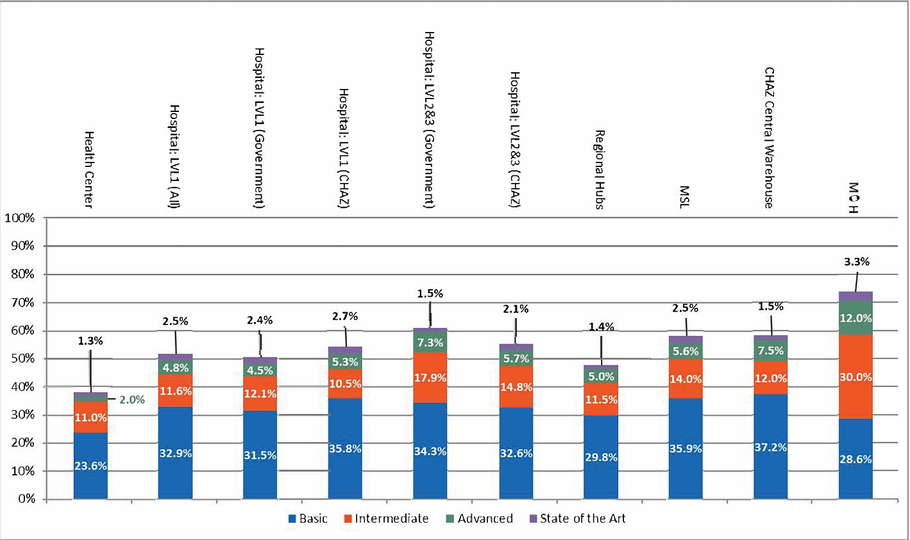

Maximum score for Basic is 50%; for Intermediate, 30%; for Advanced, 15%; for State of the Art, 5%. For instance, if the Basic portion is actually 45%, it should be interpreted as 45/50.

**Table 13. Pharmaceutical and stores management–select key capability gaps**

|  |  |  |
| --- | --- | --- |
| Indicators for MOH, CHAZ and MSL facilities | % achieved | Possible solutions |
| Power backup for cold chain systems | 16% | Procure backup power source for cold chain systems |
| Security measures | 0% | Conduct a thorough review of physical security protocols and implement protocol after it has been revised |

**Figure 6. KPI: Average stocked according to plan across facilities for tracer commodities**

s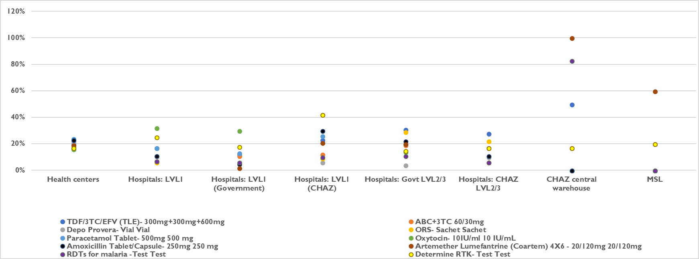

**Table 14. Pharmacy and stores management KPI score by level (average score with some ranges)**

|  |  |  |  |  |  |  |  |  |
| --- | --- | --- | --- | --- | --- | --- | --- | --- |
| Indicator | HC | Hospital LVL1 (All) | Hospital LVL2/3H (Govt) | Hospital LVL2/3H (CHAZ) | RHBs | MSL | MOH | CHAZ central |
| n= | 45 | 17 | 6* | 1** | 4 | 1 | 1 | 1 |
| Emergency orders as % of all orders | 1% | 10% | 37% | 30% | - | - | - | - |
| Stocked-according-to-plan (tracer commodities) | 20%  (16–24) | 14% (6–32) | 18% (4–31) | 15% (6–28) | - | 13%  (0-60) | - | 53% (17–100) |
| Stock out on day of assessment | 12% | 6% | 15% | 3% | - | 0% | - | 0% |
| Stock out for 182-day period: % of days out of stock in previous 6 months | 8% | 8.3% | 10% | 3.9% | - | - | - | 5.9% |
| Average number of days per month with stock out, given that there was a stock out | 12.6 | 14 | 16.4 | 16.8 | - | - | - | 13.5 |
| % of facilities with a stock-out of any tracer commodities 12/2016 to 05/2017 | 98% | 99% | 100% | 67% | - | - | - | 100% |
| Stock card accuracy  (paper-based) | 54% | 60% | 48% | 57% | - | - | - | 20% |
| Stock card accuracy deviation rate (paper-based) | 7%–111% | 9%–531% | 2%–187% | 0%–1022% | - | - | - | 6%–137% |
| Order adjustment rate  [MSL n=44 orders]  [CHAZ Central n=11] | - | - | - | - | - | 49% (0%–100%) | - | 91.6% (75%–100%) |
| Stock turn per annum (# of stock turns per year) | - | - | - | - | - | 1.2 | - | 1.7 |
| Wastage from damage, theft, expiration (% of total stock lost, damaged, or expired 10/16 to 02/17) | 0.3% | 0.7% | 0.9% | 0.0% | - | 0.0% |  | 0.0% |
| Order turn-around time (# of days between order received and order shipped) | - | - | - | - | - | 26.4 (n=20) |  | 16.0 (n=20) |
| Temperature excursion (excursions per month 12/16 – 05/17) | 1.27 | 0.75 | 0.00 | 0.00 | 0.00 | 0.00 |  | - |
| % of days with temperature outside of acceptable range (across facilities) | 8.59% | 2.90% | 0.00% | 0.00% | 0.00% | 0.00% |  | - |

*One hospital was administered the wrong questionnaire.

**Two hospitals were administered the wrong questionnaire.

**Table 15. Reason for order adjustment: % of adjusted orders at MSL and CHAZ warehouses (related to KPI 8)**

|  |  |
| --- | --- |
| MSL to health facility (N=21) | Percentage of orders adjusted |
| Stock out | 67% |
| Insufficient stock | 33% |
| Incorrect calculations | 0% |
| Product nearing expiry | 0% |
| Surplus | 0% |
| Other | 0% |

|  |  |
| --- | --- |
| CHAZ central warehouse to health facility (N=46) | Percentage of orders adjusted |
| Stock out | 4% |
| Insufficient stock | 7% |
| Incorrect calculations | 72% |
| Product nearing expiry | 11% |
| Surplus | 0% |
| Other | 0% |

**Figure 7. KPI: Average deviation from 100% stock card accuracy across facilities (no deviation = 0)**

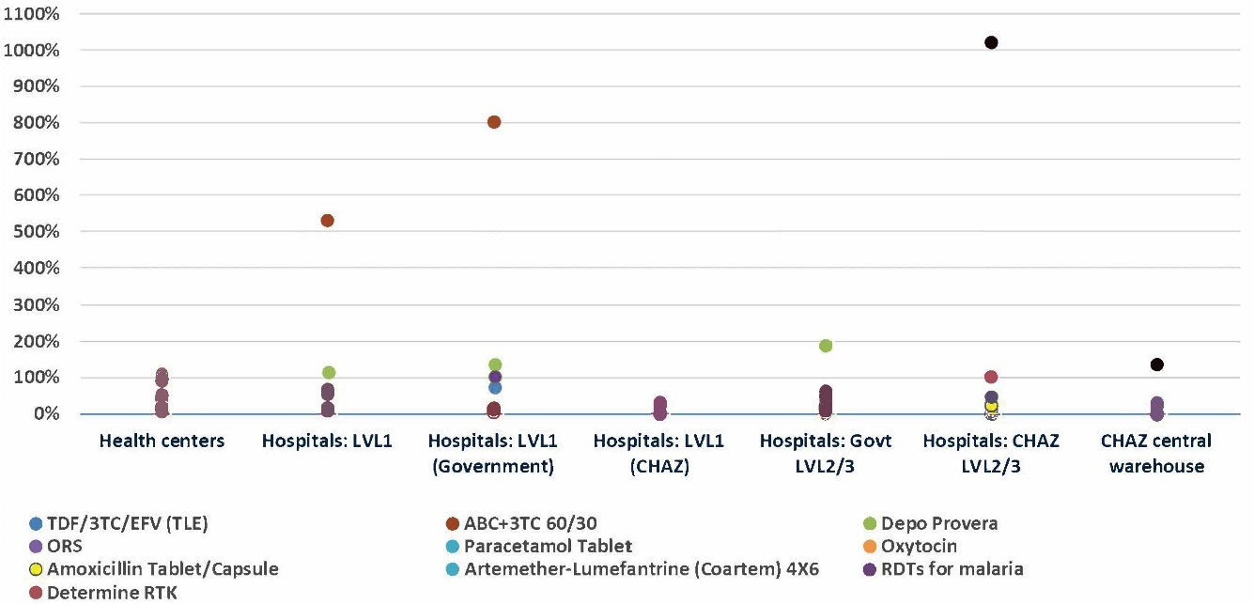

**Table 16. Average stocked according to plan across facilities**

|  |  |  |  |  |  |  |  |  |  |  |
| --- | --- | --- | --- | --- | --- | --- | --- | --- | --- | --- |
| # | Product | Product dosage | HCs | Hospitals: LVL1 | Hospitals: LVL1 (Govt) | Hospitals: LVL1 (CHAZ) | Hospitals: Govt LVL2/3 | Hospitals: CHAZ LVL2/3 | CHAZ central warehouse | MSl |
| 1 | TDF/3TC/EFV (TLE) | 300mg+300mg+600mg | 20% | 17% | 12% | 23% | 31% | 28% | 50% | 0% |
| 2 | ABC+3TC 60/30 | 30/60mg | 19% | 11% | 11% | 12% | 19% | 17% | 17% | 20% |
| 3 | Depo Provera | Vial | 22% | 11% | 13% | 6% | 4% | 10% | N/A | 20% |
| 4 | ORS | Sachet | 18% | 6% | 5% | 9% | 29% | 22% | N/A | 0% |
| 5 | Paracetamol Tablet | 500 mg | 24% | 17% | 13% | 26% | 20% | 17% | N/A | 0% |
| 6 | Oxytocin | 10 IU/mL | 16% | 32% | 30% | 42% | 14% | 17% | N/A | 0% |
| 7 | Amoxicillin tablet/capsule | 250 mg | 23% | 11% | 5% | 30% | 22% | 11% | N/A | N/A |
| 8 | Artemether-Lumefantrine (Coartem) 6x4 | 20/120mg | 19% | 7% | 2% | 21% | 20% | 6% | 100% | 60% |
| 9 | RDTs for malaria | Test | 17% | 7% | 6% | 10% | 11% | 6% | 83% | 0% |
| 10 | Determine RTK | Test | 17% | 25% | 18% | 42% | 15% | 17% | 17% | 20% |
|  |  | Range: | 16% to 24% | 6% to 32% | 2% to 30% | 6% to 42% | 4% to 31% | 6% to 28% | 17% to 100% | 0% - 60% |

**Figure 8. KPI: Average percent of facilities with stock out on day of visit across facilities**

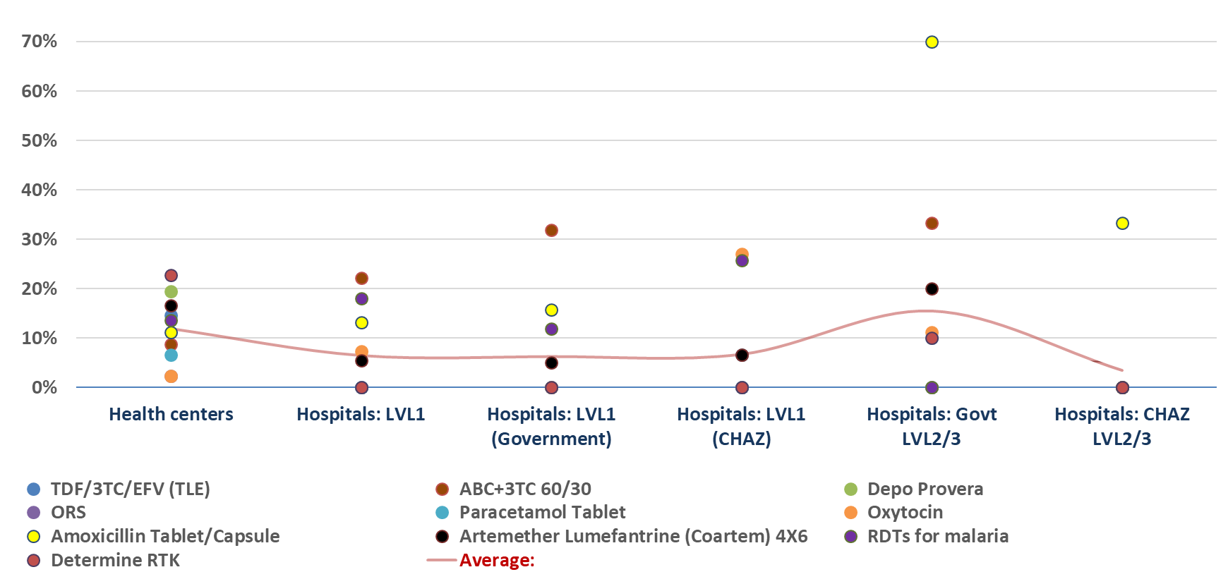

**Table 17. Percentage of facilities with stock out on day of assessment**

|  |  |  |  |  |  |  |  |  |  |  |
| --- | --- | --- | --- | --- | --- | --- | --- | --- | --- | --- |
| # | Product | Product dosage | Health centers | Hospitals: LVL1 | Hospitals: LVL1 (Govt) | Hospitals: LVL1 (CHAZ) | Hospitals: Govt LVL2/3 | Hospitals: CHAZ LVL2/3 | MSL | CHAZ central warehouse |
|  |  |  | n = 45 | n = 17 | n = 9 | n = 8 | n = 7 | n = 3 |  |  |
| 1 | TDF/3TC/EFV (TLE) | 300mg+300mg+600mg | 15% | 0% | 0% | 0% | 0% | 0% | 0% | 0% |
| 2 | ABC+3TC 60/30 | 30/60mg | 9% | 22% | 32% | 0% | 33% | 0% | 0% | 0% |
| 3 | Depo Provera | Vial | 20% | 0% | 0% | 0% | 0% | 0% | - | - |
| 4 | ORS | Sachet | 2% | 0% | 0% | 0% | 0% | 0% | - | - |
| 5 | Paracetamol tablet | 500 mg | 7% | 0% | 0% | 0% | 10% | 0% | - | - |
| 6 | Oxytocin | 10 IU/mL | 2% | 7% | 0% | 27% | 11% | 0% | 0% | - |
| 7 | Amoxicillin tablet/capsule | 250 mg | 11% | 13% | 16% | 7% | 70% | 33% | - | - |
| 8a | Artemether-Lumefantrine (Coartem) 6x4 | 20/120mg | 17% | 5% | 5% | 7% | 20% | 0% | 0% | 0% |
| 8b | Artemether-Lumefantrine (Coartem) 6x1 | - | 36% | 20% | 27% | 0% | 30% | 33% | 0% | 0% |
| 8c | Artemether-Lumefantrine (Coartem) 6x2 | - | 29% | 17% | 13% | 27% | 10% | 33% | 0% | 0% |
| 8d | Artemether-Lumefantrine (Coartem) 6x3 | - | 29% | 29% | 27% | 34% | 30% | 33% | 0% | 0% |
| 8e | All Artemether-Lumefantrine (Coartem) | - | 0% | 4% | 5% | 0% | 0% | 0% | 0% | 0% |
| 9 | RDTs for malaria | Test | 14% | 18% | 12% | 26% | 0% | 0% | 0% | 0% |
| 10 | Determine RTK | Test | 23% | 0% | 0% | 0% | 10% | 0% | 0% | 0% |
| Overall: |  |  | 12% | *6%* | 6% | 7% | 15% | 3% | 0% | 0% |

Summary of Results

Across all levels of service engaged in pharmacy and store management, none reached an overall greater score than 74% of the total, only MOH attained the maximum possible score within the intermediate band, none other attained the maximum score in any of the other bands—basic, advanced, and state-of-the-art maturity levels. Basic maturity scores for pharmacy and stores management are 23.6%–37,2% across all levels of service or facilities. This is an area for concern as it directly affects the availability of health commodities for patients. Average stocked according to plan results at government hospitals and HCs are at 20% or below, and stock outs range from 6% to 15%; average stock out days ranging from 12.6 days to 16.4 days. Average deviation from stock accuracy varies from 0% to 1,022% across both organizations. Stock out rates of any tracer commodities by facilities across all levels is 67%. Emergency orders are higher in LVL2/3H government and CHAZ hospitals at 37% and 30% compared to HC and LVL1Hs at 1% and 10%.

Wastage from damage, theft, and expiration is below 0.9% across all facilities. The number of days with temperatures outside the acceptable range (-0.5˚C to 8˚C) is satisfactory where data is available, the only excursions reported are at the government hospitals 0.75 days per month, and HCs 1.27 days. However, it should be noted that 89% of health facilities were not recording temperature excursions. Internal audits are performed at the pharmacy stores annually in 89% of facilities and verification of outbound orders are conducted in 100% of facilities assessed, and 100% of the hubs had expiry tracking registers. However, 84% of facilities lack power backup systems for cold chain, 100% of facilities lacked security measures (e.g., Radio Frequency Identification (RFID) tags, video or GPS monitoring, unannounced inspections, etc.).

Discussion

The observed low maturity and performance against key indicators for selected tracer commodities suggests the need for considerable improvement in pharmacy and stores management. Stocked according to plan levels that are consistently below 54% and as low as 14% are indicative of poor inventory management and stock management practices at all levels of the supply chain system. This is corroborated by moderate to high degrees of order adjustments and emergency orders, which may be related to stock management practices that are conducted in a nonroutine fashion. Inventory turns of 1.2 and 1.7 in MSL and CHAZ central warehouses may be linked to some of the stock levels at lower levels of the supply chain and are indicative of MSL and CHAZ stores keeping excessive inventory on hand than is needed which could expire.

Stock out rates of at least one tracer commodity per facility may be linked to insufficient stocks at MSL—33% of orders placed are adjusted for this reason. Stock accuracy rates underpin the quality of LMIS data, which affects forecast accuracy, accuracy of orders, and incorrect calculations resulting in order adjustments. Stock card accuracy is weak, leading to potential problems downstream in the supply chain processes. The supply chain assessment linked stock card accuracy with the issues of stock availability.. Pharmacies at the district health offices (DHOs) do not feature prominently in the supply chain structure, but these facilities contribute to the health supply chain in a meaningful way. The DHO support of HCs is important, but it is also necessary to consider what is stored and for how long. It was observed by the data collection teams that DHOs are retaining up to one to two months of stock from MSL to support health center needs for emergency orders, but turnover is not always tracked; this circumstance could result in pockets of aging inventory. For example, oxytocin has a high stock out rate across the system with relatively low quality and product testing results at MSL and CHAZ (17% and 75% respectively). Coupled with the situation where some facilities visited were not tracking temperature, this could increase risk of expired or compromised product.

The lowest performing link in the ordering process is fulfillment as facilities are ordering on time, but turnaround and delivery are not efficient. The on-time numbers indicate only one-half to two-thirds of orders are on time, and the turnaround time for the public sector is almost a month.

90% of the health facilities are not tracking temperature excursions. Poor cold chain management, especially at the health facility level, is affected by the absence of power backup systems, monitoring, and recording systems putting cold chain items and patients at risk.

Recommendations

* Inventory management and control need to be strengthened through training, supportive supervision, mentoring, and data quality reviews.
* Efforts must be concentrated at all levels to ensure equipment for storage and inventory management are provided and staff are trained in pharmacy and stores management to improve performance.
* MOH should conduct an equipment and records assessment to determine the requirements for cold chain backup, monitoring, and tracking and raise funds to equip HCs with inverters and solar equipment. This should include regular supply of monitoring and tracking tools.
* Security audits (to review adherence to facility security standards including physical, electronic and establishment of security procedures) should be conducted to identify and address gaps.
* Although space availability was not assessed extensively during the assessment, there is need for a separate space needs and optimization assessment to determine and address space needed to accommodate planned stock levels, as this affects facilities ability to stock according to plan.
* When the RHBs are operational nationwide, MOH should review whether it is necessary for DHOs to continue to store health commodities.
* DHOs operate as pharmacy stores for health facilities, especially HCs with limited storage space. In some instances, the DHOs are located within the vicinity of a health facility, and their store becomes the store for the health facility. It is recommended that these stores should be made structural components of the supply chain system in Zambia, properly equipped and staffed to be able to effectively manage inventory for supply to the health facilities, if they are to remain part of the supply chain.
* MSL and CHAZ warehouses should ensure that inventory turns align with ordering and distribution cycles. Inventory turns should be measured consistently to preclude waste and expiries for commodities that are sitting for too long in the central warehouses.

### Distribution

**Figure 9. Distribution CMM score per level of achievement by level**

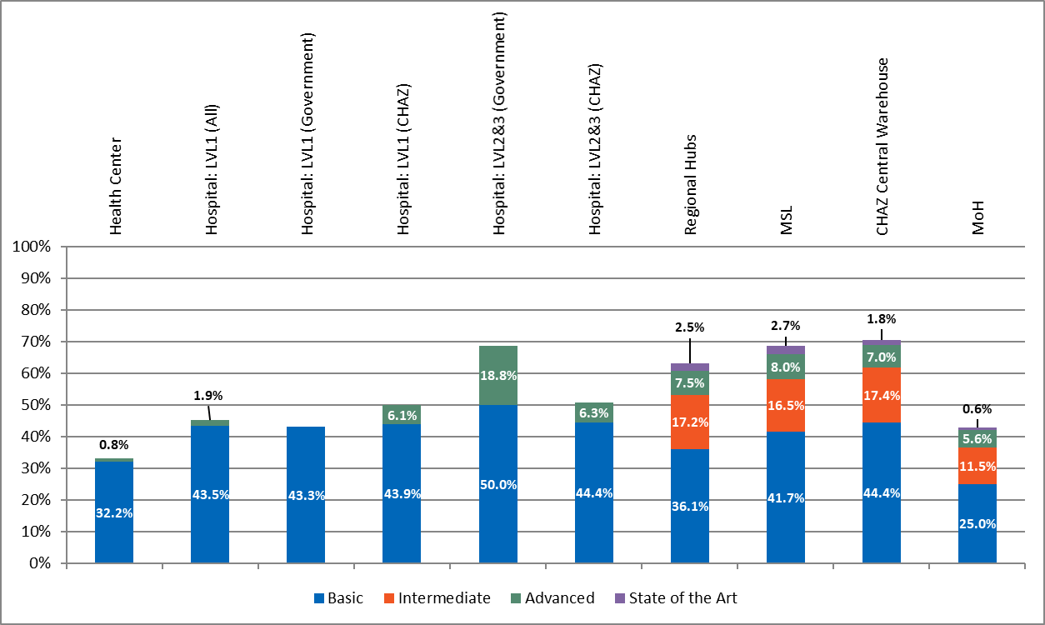

Maximum score for Basic is 50%; for Intermediate, 30%; for Advanced, 15%; for State of the Art, 5%. For instance, if the Basic portion is actually 45%, it should be interpreted as 45/50.

**Table 18. KPI 13: On-time delivery to facility (routine order)**

|  |  |  |  |  |
| --- | --- | --- | --- | --- |
| Unit receiving  the order | Number orders sampled | Number of orders with full data | Percentage delivered on or before promised delivery date | Percentage delivered within two days of promised delivery date |
| Health centers* | 127 | 6 | 33% | 67% |
| Hospitals: LVL1 | 64 | 31 | 35% | 23% |
| Hospitals: LVL1 (govt) | 28 | 9 | 56% | 11% |
| Hospitals: LVL1 (CHAZ) | 36 | 22 | 27% | 27% |
| Hospitals: Govt LVL2/3 | 42 | 20 | 50% | 15% |
| Hospitals: CHAZ LVL2/3 | 14 | 12 | 50% | 8% |

*Very little data from the HC level.

Summary of Results

The overall maturity scores for distribution are above 50% at the LVL2/3H government hospitals, hubs, MSL, CHAZ, and all the CHAZ hospitals. However, the MOH and HCs have a low maturity for distribution with accompanying low scores under basic elements; while MOH does not maintain stores or distribute directly, it is responsible for oversight of facilities that do. The relatively low scores in the basic elements (36.1%) are also observed under the **hubs** despite scoring in the intermediate (17.2% out of 30%) and advanced (7.5% out of 15%) maturity levels. However, performance does not match capability maturity. On-time delivery at the government hospitals LVL 1, 2 &3 and CHAZ hospitals LVL2/3H were around 50% for percentage of commodities delivered on or before promised delivery date and below this performance at the lower levels facilities. Most emergency orders were registered at both the CHAZ and government hospital LVL2/3H facilities, and 100% (CHAZ) and 0% (government hospital LVL2/3H facilities) of these emergency orders were delivered within two days of the promised delivery dates. The government of Zambia contributes more than 50% of the distribution budget. MSL has a well-posted distribution schedule. However, distribution plans were not disseminated by MSL to the hubs in advance of supplying commodities. Additionally, routing plans do not take into consideration volumes, geographical locations, and weights of the individual products. There was limited infrastructure for cold chain transportation.

Discussion

The observed average maturity for the LVL2/3H government hospitals, hubs, MSL, CHAZ, and all the CHAZ hospitals are above the average performance in on-time delivery at all levels. However, the on-time delivery KPI shows less than 60% of deliveries made within two days of the promised delivery date. On-time delivery is essential to ensure that commodities are stocked according to plan within the max-min levels. Considerable emergency orders were recorded at the higher-level facilities, MSL, and CHAZ warehouses. It appears that MSL prioritizes emergency orders for hospitals considering that 37% (CHAZ) and 30% (government) of all orders were emergency in nature. The emergency orders appear to be related to poor stock according to plan performance as discussed in the prior section (pharmacy and store management). There is need to optimize the distribution network as evidenced by the reliance on MSL to make direct-drop deliveries to all health facilities at different levels of the health system. The district health offices that could serve as intermediate hubs or cross-docking facilities are currently not holding more than one month’s stock and are therefore not in a position to adequately refill any orders including emergency orders. Using the district health offices as RHBs is further compounded by the lack of shared advanced information between MSL and the DHOs, thus making it difficult for the district health offices to create adequate space to hold more stock. Finally, the distribution network could be improved by the consideration of volume, weight, geographical location and other distribution elements when designing the routing plans.

It is expected that the new RHBs will improve distribution by acting as a quick response intermediary facility between MSL and the HCs. Until the RHBs are fully operational, it would be premature to make further changes to the system.

Recommendations

* Once the RHBs are fully operational, a distribution optimization analysis should be conducted to identify opportunities for improvement, efficiencies, and savings, with an appropriate implementation plan.
* MSL should disseminate the approved distribution plans with all the hubs in advance of supplying commodities to ensure preparation in receiving the commodities.
* MSL routing plans should consider weights, geographical location, and volumes.

### Policy and Governance

**Figure 10. Policy and governance CMM score per level of achievement by level**

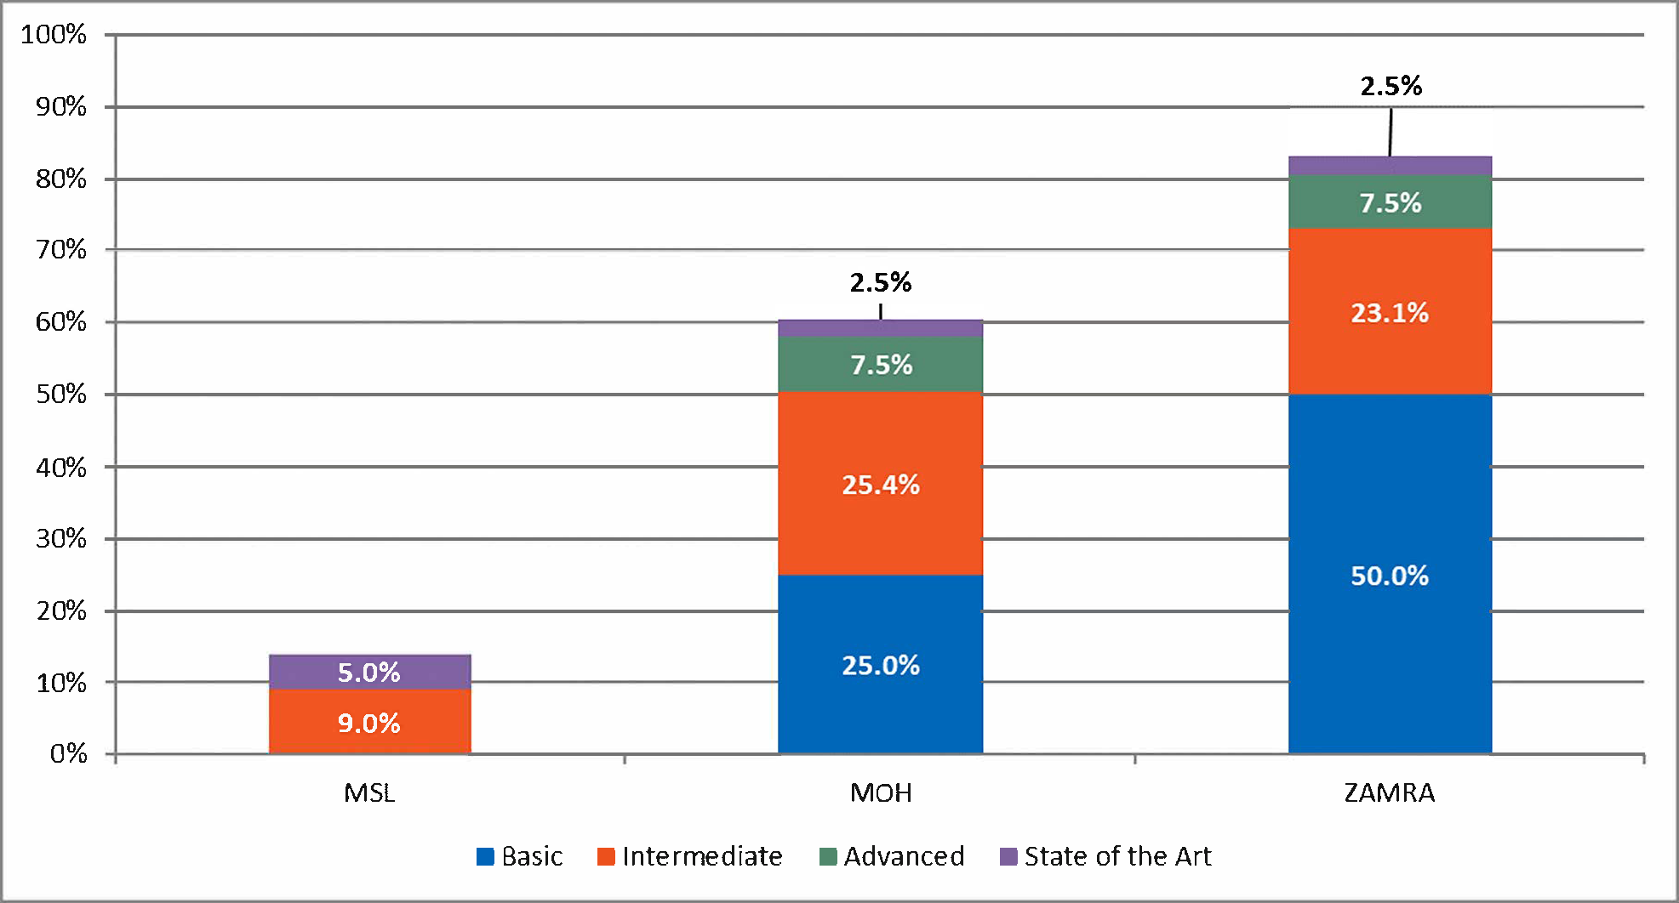Maximum score for Basic is 50%; for Intermediate, 30%; for Advanced, 15%; for State of the Art, 5%. For instance, if the Basic portion is actually 45%, it should be interpreted as 45/50.

Summary of Results and Discussion

The overall scores vary widely from 14% to 83% across MSL, MOH, and ZAMRA. The score for policy and governance at the MOH is low at about 25% out of a possible 50% for the basic maturity band. The gaps indicate an absence of documented policies and guidelines for the supply chain system at the MSL. There are good practices in the Zambia supply chain system such as the use of standard treatment guidelines, which help to streamline products selection and improves the procurement process. The registration of products ensures that commodities that comply with guidelines and laws of Zambia are available in the health commodity supply chain system. The assessment revealed that registered products lists are published to ease selection for procurement. While ZAMRA CMM scores are presented separately in figure 10 above, ZAMRA and MOH CMM scores are interrelated and must be interpreted in that light. ZAMRA executes specific functions that are designated by the MOH. Consequently, ZAMRA’s maturity scores are higher than MOH’s maturity scores in relation to policy, because ZAMRA is the designated authority within MOH organizational structure to establish the National Medicines Policy. MOH’s CMM scores reflect broader governance and policy issues.

Recommendations

The MOH should ensure that policy documentation and guidelines are disseminated to the requisite staff and entities at national and subnational levels, and these entities maintain the documents in an easily accessible location so they can be quickly referenced. MOH must also follow up the dissemination of these guidelines with routine refresher trainings to entrench a shared understanding of its policies and guidelines.

### Strategic Planning and Management

**Figure 11. Strategic planning and management CMM score per level of achievement by level**

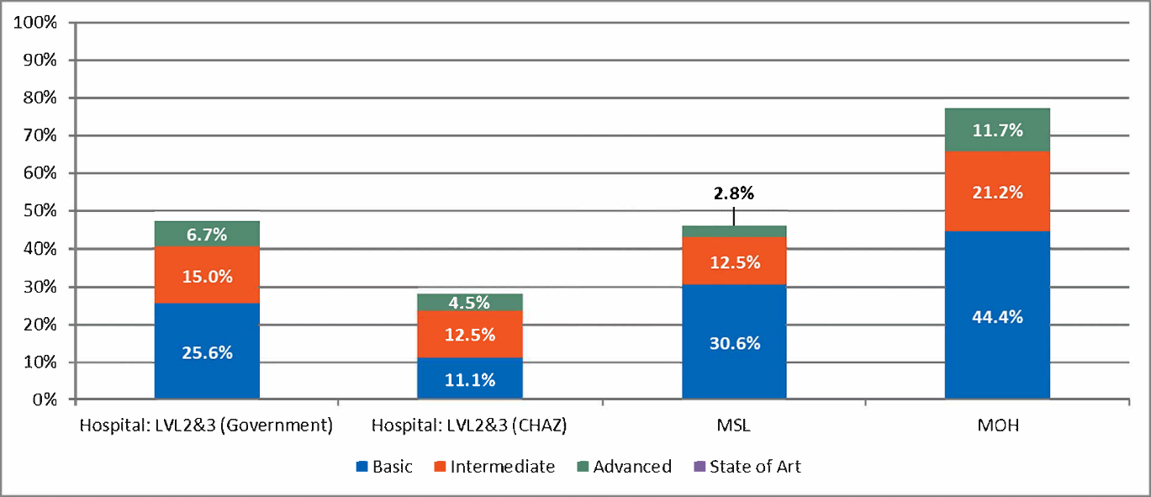

Maximum score for Basic is 50%; for Intermediate, 30%; for Advanced, 15%; for State of the Art, 5%. For instance, if the Basic portion is actually 45%, it should be interpreted as 45/50.

Summary of Results and Discussion

Strategic planning and management scores are high for the MOH, with a value of 44% of a maximum 50% for Basic items. At the MSL, however, the score is lower, with a score of 31% out of 50% and 26% out of 50% for Basic items at the LVL2/3H government-supported health facilities. Gaps suggest a lack of robust strategic planning at MSL and the hospitals.

Recommendations

MOH should support MSL and government hospitals to ensure that appropriate strategic plans are in place that reflect the MOH strategic plan and are implemented to guide operations at those levels.

### Quality Assurance and Pharmacovigilance

**Figure 12. Quality assurance and pharmacovigilance CMM score per level of achievement by level**

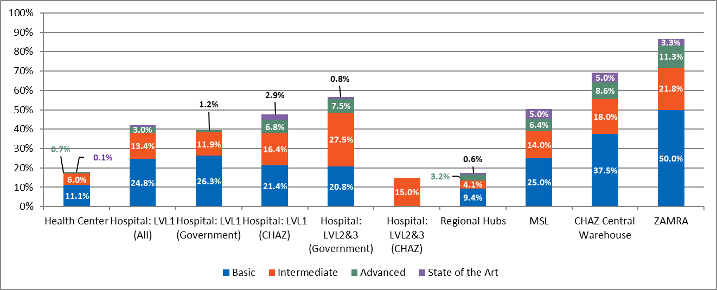

Maximum score for Basic is 50%; for Intermediate, 30%; for Advanced, 15%; for State of the Art, 5%. For instance, if the Basic portion is actually 45%, it should be interpreted as 45/50.

Summary of Results

ZAMRA operates a good QA system, checking drugs as they enter the system. This is reflected in an overall maturity score of 86%. The maturity scores for QPV were low across the lower levels of the supply chain. The CHAZ warehouse scored high at 70% with the MSL and LVL2/3H government hospitals scoring 50% and 59%, respectively. At health facilities where patient related adverse events would be reported, scores were low.

CHAZ LVL2/3H hospitals, RHBs, and HCs scored in the low range at 15%, 17%, and 18%, respectively overall. Basic elements required to operate QPV were also low with a range of 0%–38%. CHAZ LVL2/3H hospitals did not have any basic elements to run a pharmacovigilance system. However, the CHAZ warehouse scored had more than half of the basic elements for a score of 38%. On a positive note, QPV data at 89% of LVL1 hospitals are shared with the central or higher-level authorities.

Discussion

Although drugs from suppliers are checked for quality when entering the system, there is a lack of a consistent approach to QPV further down the supply chain. This is explained by the low funding offered by the government. This area requires attention from government as the safety of drugs consumed could be questionable, thus putting patients’ lives at risk. It is best practice that when QPV data is collected at hospitals and health facilities, this data is shared with the regulatory authority and the MOH so that action protocols are followed in case of adverse drug reactions (ADRs) and poor-quality medicines. This aspect is observed at the LVL1H but not other levels, posing a risk.

Recommendations

* MOH and MSL should collaborate with ZAMRA to develop SOP for pharmacovigilance, train staff on the SOP, and disseminate to ensure compliance by all staff.
* ZAMRA and MOH should work with development partners to put in place a strong QPV system with tools, procedures/processes, infrastructure, and the human resources. This will reinforce the capability of ZAMRA to steer QPV.
* Tools should be made available across the entire system to support improved QPV.
* Reports should be collated and analyzed; subsequently, informed decisions should be made from the results.

### LMIS

**Figure 13. LMIS CMM score per level of achievement by level**

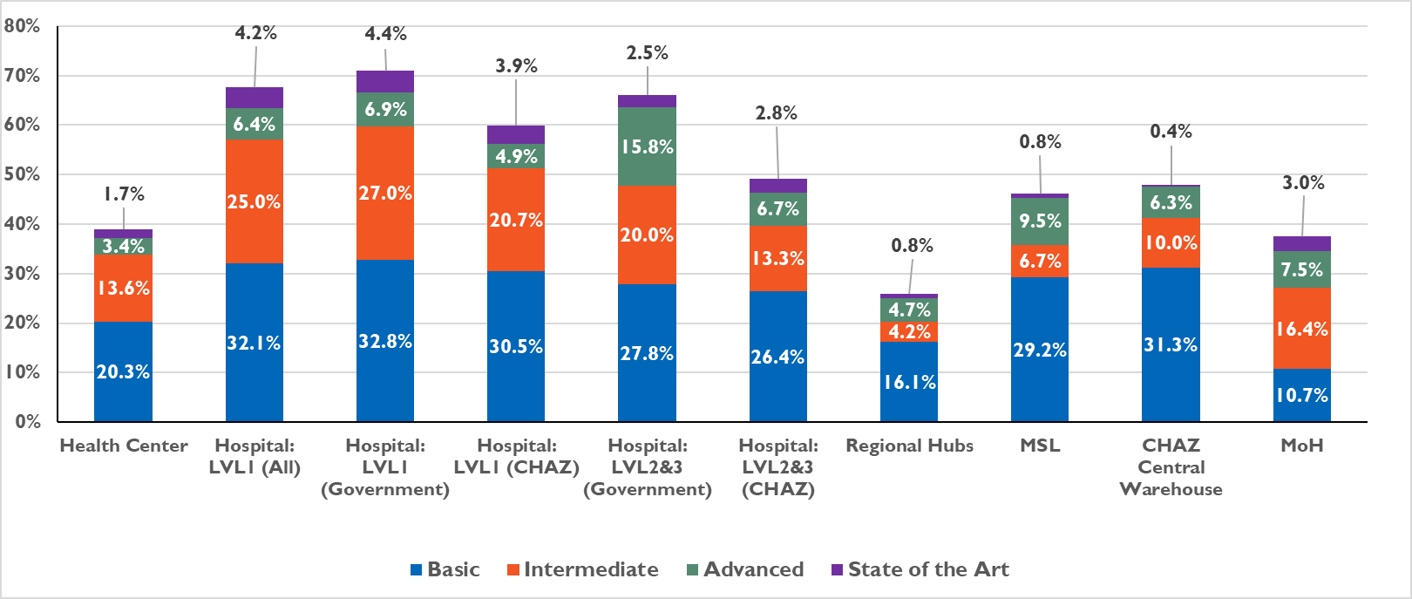

Maximum score for Basic is 50%; for Intermediate, 30%; for Advanced, 15%; for State of the Art, 5%. For instance, if the Basic portion is actually 45%, it should be interpreted as 45/50.

**Table 19. LMIS KPI scores by level**

|  |  |  |  |  |  |  |  |  |
| --- | --- | --- | --- | --- | --- | --- | --- | --- |
| Indicator | HC | Hospital LVL1 (all) | Hospital LVL2/3H (govt) | Hospital LVL2/3H (CHAZ) | RHBs | MSL | MOH | CHAZ central |
| n= | 45 | 17 | 9 | 8 | 4 | 1 | 1 | 1 |
| KPI 15–eLMIS data updated in the last 7 days (average) | 48% | 34% | 22% | 63% | - | 100% | - | - |
| KPI 5a–Stock accuracy for eLMIS (average) | 32% | 34% | 11% | 33% | - | 0% | - | 40% |
| KPI 5b–Average deviation from 100% accuracy [no deviation = 0)] (range across tracer products) | 32% (3–56) | 144% (31–568) | 533% (12–4765) | 37% (0–67) | - | 1% (0–92) | - | 2% (0.1–24) |

**Figure 14. KPI–eLMIS data updated in the last seven days before assessment visit (of those with available eLMIS record for product)**

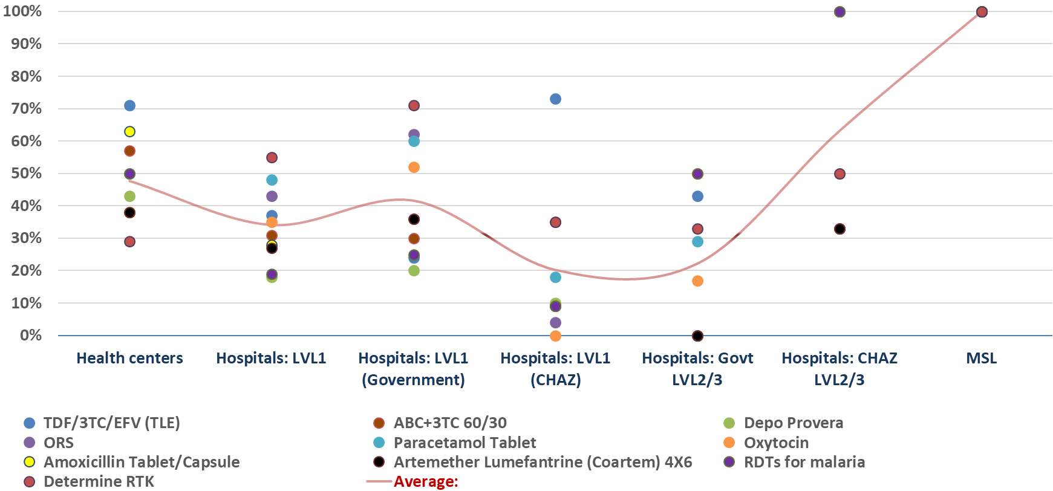

* Dots represent the 10-tracer commodities.

**Figure 15. KPI–eLMIS accuracy: Percent of facilities at 100%**

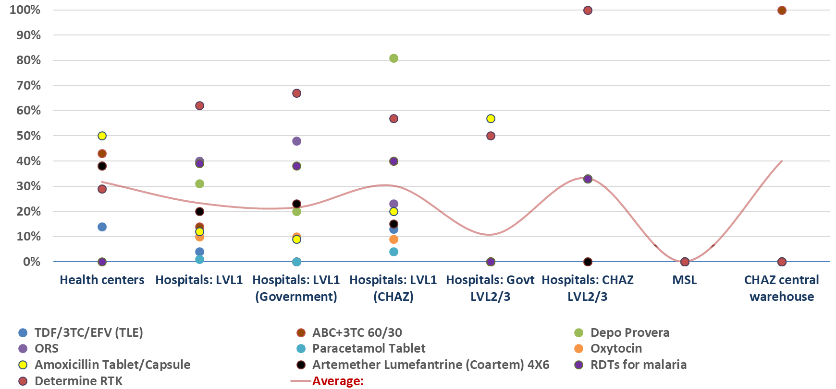

Summary of Results

The maturity scores were highest at LVL1H for both government and CHAZ-supported facilities and LVL2/3H for government hospitals at 71%, 60%, and 66%. The RHBs had the lowest maturity score at 26%. This may be reflective of being new facilities. Selection, ordering, and reporting are informed by LMIS activities at 83% of facilities assessed. Reverse logistics and redistribution are not informed by the LMIS at MSL. At MSL, eLMIS data was found to be updated in the last seven days, compared to hospitals and HCs that were below 60%. Government LVL2/3H hospitals had the lowest percentage at 22%. Stock accuracy was low across all levels of the supply chain, with a range of 11% to 40%. Very large variations in deviations from 100% accuracy ranging from 1% to 533% deviation were observed. It is important to note that Zambia is rolling out a phased implementation of the eLMIS system, and not all facilities are set to be online until the end of 2018. The eLMIS was not yet set up at the lower levels of the supply chain, explaining the absence of eLMIS data at the lower levels. Internet interruptions were also experienced in some facilities that were assessed.

Discussion

The low maturity scores are associated with poor accuracy of LMIS data (e.g., stock accuracy, consumption data, losses, and adjustments leading to incorrect orders). Across both manual and eLMIS systems, information is not as accurate as it could be at this time. Particularly, remote areas were challenged in keeping LMIS systems up to date; this challenge is partially due to internet connectivity issues, as well as facilities being understaffed (making it difficult to find extra staff time to update the LMIS). For the manual LMIS challenges, it appears that high-volume facilities struggle more to maintain the LMIS. This situation may be due to the other duties competing for limited staff time. The combination of stock outs and poor LMIS data appear to compound emergency ordering. The absence of eLMIS as well as internet interruptions frustrate efforts to access and share eLMIS data on time. In the absence of accurate and timely data, the forecasting and quantification process is affected, with an impact on procurement. Duplication of manual and eLMIS at facilities with both is inefficient and creates additional workload.

Recommendations

* The rollout of eLMIS at the lower-level health facilities should be supported and facilities trained in its use.
* Strengthen support supervision and mentoring including conducting data quality assessment to improve data accuracy.
* Training and retraining should occur regularly in quality of LMIS data and SOP.
* When the rollout of the eLMIS system is complete, the MOH should conduct another review of LMIS KPIs to assess accuracy and timeliness. As performance improves with regular use of the eLMIS system, the MOH should retire the paper-based LMIS.

### Human Resources

**Figure 16. Human resources CMM score per level of achievement by level**

**Table 20. Human resources KPI score by level**

|  |  |  |  |  |  |  |  |  |
| --- | --- | --- | --- | --- | --- | --- | --- | --- |
| Indicator | HC | Hospital LVL1 (all) | Hospital LVL2/3H (govt) | Hospital LVL2/3H (CHAZ) | Regional hubs | MSL | MOH | CHAZ central |
| n= | 45 | 17 | 9 | 8 | 4 | 1 | 1 | 1 |
| KPI 14a—% of key positions filled on day of visit | 82% | 61% | 99% | 75% | 97% | 90% | - | - |
| KPI 14b—% of staff leaving (2016) | 7% | 14% | 0% | 15% | 0% | 50% | - | - |
| % of facilities with no vacancies | 67% | 41% | 71% | 0% | 89% | 0% | - | - |

Maximum score for Basic is 50%; for Intermediate, 30%; for Advanced, 15%; for State of the Art, 5%. For instance, if the Basic portion is actually 45%, it should be interpreted as 45/50.

Summary of Results

Overall, most of the facilities have HR capability maturity scores between 35% and 55%, except for MOH and ZAMRA that have exceedingly high scores of 84% and 85%, respectively. More specifically, basic maturity scores for MOH and ZAMRA are at the maximum of 50%, while basic maturity scores of 40% or less are seen across all the other facilities. An underpinning achievement for the HR CMM is that the budget for supply chain personnel is fully funded by the government. The KPI analysis shows more consistently positive scores for many facilities, with low levels of vacancies at the HC, LVL1H, and LVL2/3H, and acceptable levels of staff turnover of 15% and below (except for MSL). However, clear capability and maturity gaps still exist as evidenced by the absence of clear job descriptions required to guide the activities of supply chain staff, and the use of training curriculum that is devoid of key supply chain activities such as forecasting and quantification.

Discussion

HR results are satisfactory for both capability maturity and KPIs at the central levels, but capabilities in supply chain management decline in the facilities at lower levels of the supply chain. While a more in-depth analysis is required to pinpoint reasons for the decline in maturity scores from high to low levels of the supply chain system, some evidence points to the fact that supply chain is not regarded as high a priority at subnational facilities as service delivery and patient care-related activities. Additionally, there is scope for further improvement in routine training and supportive supervision especially in the HCs to support staff for whom supply chain is not their priority. It is noticeable that many intermediate-level capabilities are in place, while basic capabilities are lacking. Targeted actions to bring the basic capabilities up to the required standards could lead to an accompanying overall increase in intermediate capability maturity rating across most of the facilities.

Recommendations

* Efforts should be made to train staff in all aspects of supply chain management.
* A pool of master trainers should be developed to ensure total coverage of training in supply chain management.
* Job descriptions should be developed for all supply chain positions and made available to all relevant staff.

### Financial Sustainability

**Figure 17. Financial sustainability CMM score per level of achievement by level**

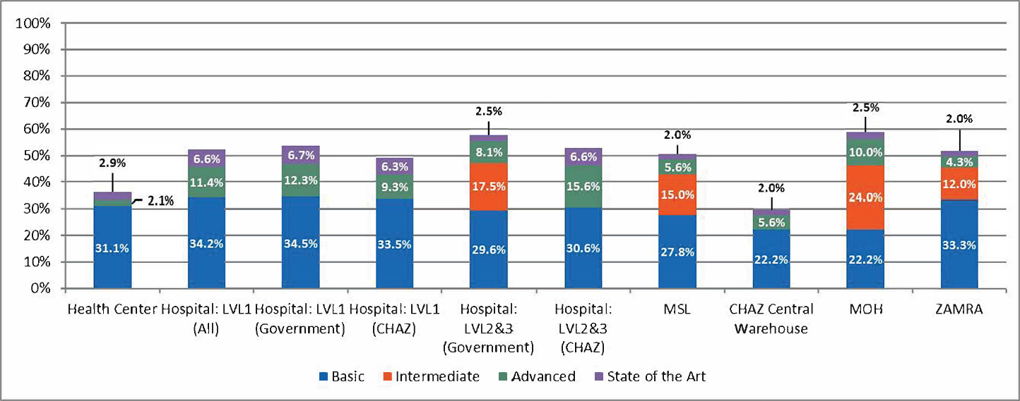

Maximum score for Basic is 50%; for Intermediate, 30%; for Advanced, 15%; for State of the Art, 5%. For instance, if the Basic portion is actually 45%, it should be interpreted as 45/50.

Summary of Results and Discussion

Overall capability maturity scores range from 30% to 58% across all facilities. More specifically, it is instructive to note that at the MOH, the basic maturity score for financial sustainability is low (22%), and the intermediate maturity score at the MOH is relatively high (24% out of 30%). The highest basic maturity score across all facilities is 34.5% (LVL1H government hospitals). One of the factors underpinning the financial sustainability achievements at the MOH is the fact that there are systems in place to address shortages in budgets at the central level, which encompasses MOH reallocation of funds and targeted budget cuts. Another specific achievement is that the government has a system of routinely tracking donor support to the country health system. Conversely, a few gaps underlie the above-mentioned results: the existence of relatively weak systems at the HCs to provide enough funds for activities throughout the year and the inability of governments to address shortfalls in a timely manner. While some of these shortfalls may be a direct result of an overall shortage of funds at MOH, the assessment team to could not establish the root cause for budget shortfalls at subnational level facilities.

Recommendations

Medium- to long-term plans should be put in place in a strategic plan to address long-term sustainability of procurement funding by the MOH and GRZ.

### Waste Management

**Figure 18 Waste management CMM score per level of achievement by level**

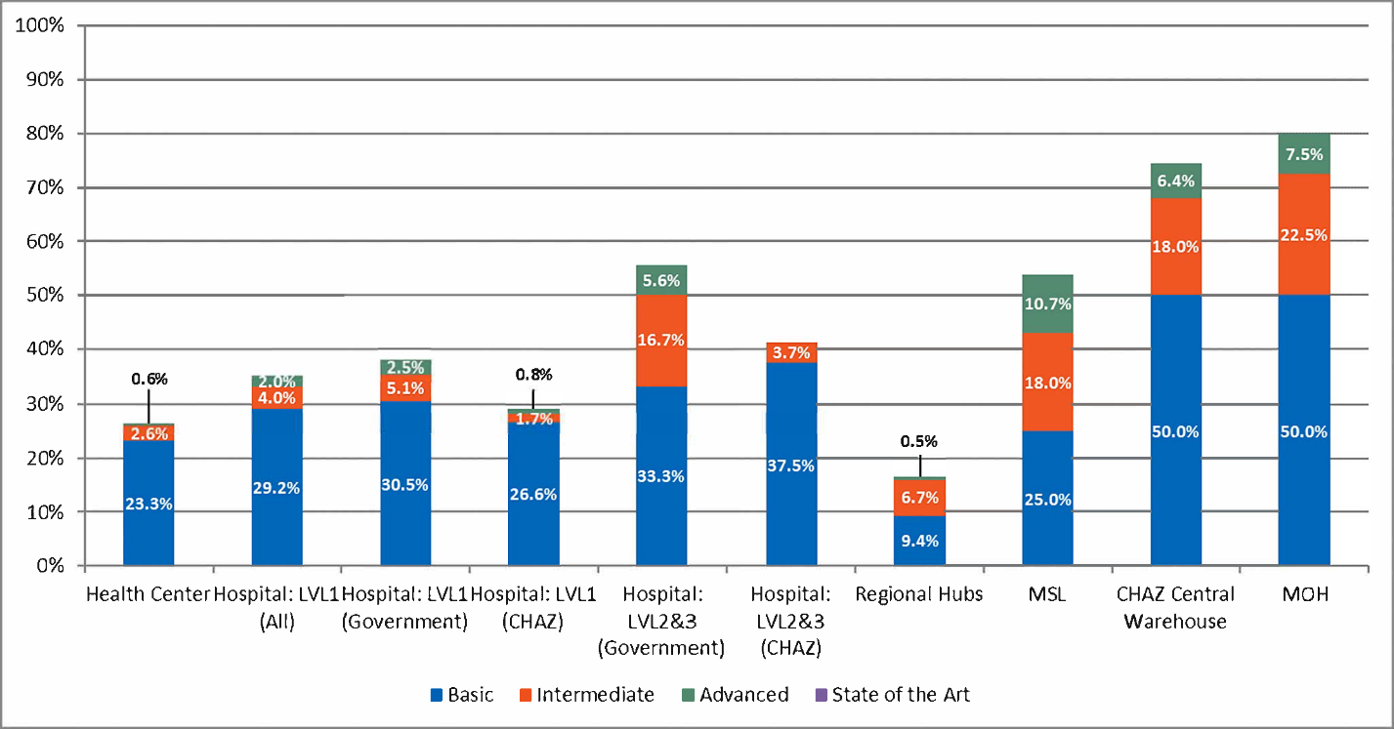

*Maximum score for Basic is 50%; for Intermediate, 30%; for Advanced, 15%; for State of the Art, 5%. For instance, if the Basic portion is actually 45%, it should be interpreted as 45/50.*

Summary of Results

The waste management overall maturity scores range from 17% at the hubs to 74% at CHAZ and 80% at MOH. The maturity scores are the lowest at the lower-level facilities and highest at MOH, CHAZ warehouse, and LVL2/3H government hospitals. It is important to note that MSL shows a surprisingly low score for the waste management basic functions (25%). The CHAZ central warehouse and the MOH had all the required basic elements necessary to operate waste management functions, while the RHBs do not have the required basic elements (9%) to operate a waste management function. It was observed that waste management practices at the MOH are monitored by regular collection of standard KPIs, external audits, on-site monitoring, and performance assessments. However, unusable pharmaceutical products were not stored separate from usable stock at the hubs, which poses a great risk in contamination. MSL reported that it had not disposed of waste commodities in over a year.

Discussion

Maturity scores for waste management are above 50% in some facilities, demonstrating adequate management of pharmaceutical waste. However, the maturity is low at the HCs, the hubs, and MSL. This poses a risk as any contamination of usable commodities or distribution of expired drugs can be detrimental to a wide range of facilities. Waste management at the HC, hubs, and MSL need to be prioritized. It is important to note that MOH was assessed for oversight-related functions such as the availability of waste management guidelines, procedures, and monitoring, whereas MSL was assessed for execution of these waste management procedures and policies. A more nuanced waste management issue identified at MSL was the lack of evidence for disposal of waste commodities in over a year.

Recommendations

* SOP that clearly spell out the best practice for storing unusable pharmaceutical products should be disseminated by MOH in collaboration with MSL to all hubs and support supervision visits done to ensure compliance.
* Special attention should also be paid to the lower-level health facilities, especially the HCs, by setting up a waste management system.
* The backlog of waste at MSL should be disposed of as soon as possible.

## By Level of Service: Overall CMM and KPI Results

The results of the assessment were also analyzed by looking at the data from the perspective of the various levels. The following provides key data results, followed by key capability achievements and key capability gaps (if the gaps and achievements findings were meaningful).The full set of data results is available for reference in Annexes 3 and 5.

### Health Center

**Table 21. HC CMM score by module (average score and range) (N=45)**

|  |  |  |  |
| --- | --- | --- | --- |
| Module | Average % | Module | Average % |
| Forecasting and supply planning | - | Human resources | 37%  (7%–70%) |
| Procurement | - | Financial sustainability | 36%  (0%–75%) |
| Pharmacy and stores management | 38%  (21%–56%) | Policy and governance | - |
| Distribution and receiving | 33%  (0%–54%) | QPV | 18%  (0%–70%) |
| Waste management | 26%  (0%–63%) | LMIS | 39%  (0%–90%) |
| Strategic planning and management | - |  |  |

**Figure 19. HC level of achievement by functional area**

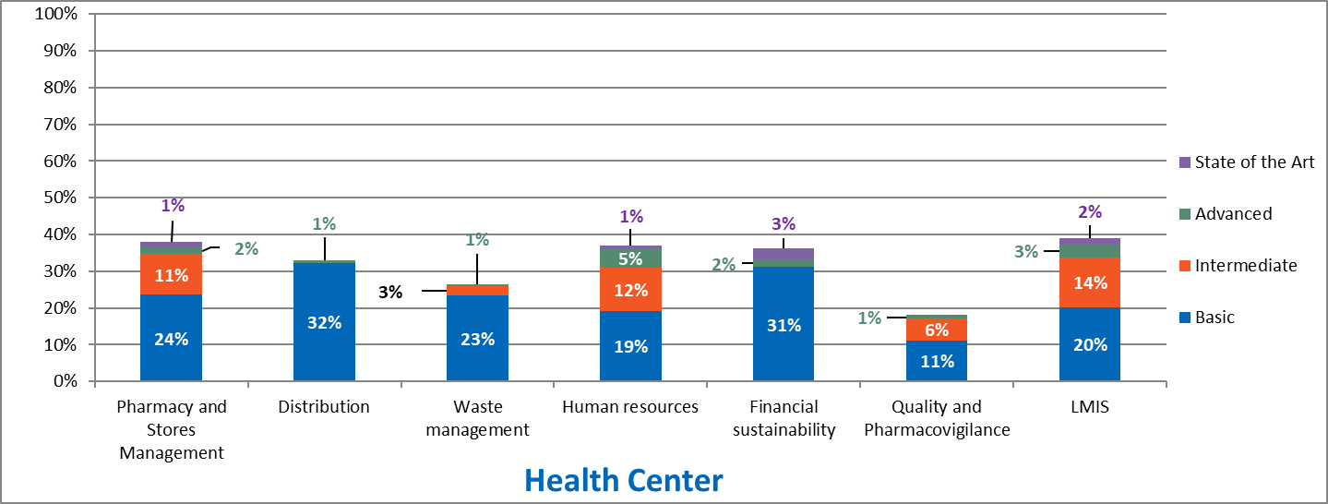

Maximum score for Basic is 50%; for Intermediate, 30%; for Advanced, 15%; for State of the Art, 5%. For instance, if the Basic portion is actually 45%, it should be interpreted as 45/50.

**Table 22. Select KPI results for HC**

|  |  |
| --- | --- |
| Indicators | HC |
| Average # of days per month with stock outs (overall for tracer commodities) | 12.6 |
| % of tracer commodities, out-of-stock on day of visit (overall) | 12% |
| % of orders delivered within two days of promised delivery date | 67%* |
| % of emergency orders, out of all orders | 1% |
| % of facilities with any stock outs of any of the 10-tracer commodities December 2016–May 2017 | 98% |

*Based on a very small data set and not reliable as an indicator of performance.

Summary of Results

Overall maturity scores for the health facilities were generally below desired levels with a range of 18%–39%; QPV scored the lowest (18%) and LMIS the highest (39%). That said, the government is responsible for funding the human resource budget at 93% of HCs and the inventory control system includes the min-max set points. However, only 18% of HCs had capacity-building sessions that included forecasting and quantification, and the same proportion of HCs did not have access to internet. Similarly, only 4% of HCs received a distribution schedule in advance from the hubs and districts, and 13% of HCs did not have data quality assessments conducted. KPIs at the HCs were poor with moderate stock-out severity at the HC level, as evidenced by an average number of stock-out days of 12.6 days. An average of 12% of HCs were stocked out of tracer products on the day of the visit, and 98% of HCs were stocked out of ***any*** of the tracer products between December 2016-May 2017. There were few emergency orders at the HC level, as 1% of all orders were emergency orders. Timeliness of deliveries was fair as 67% of facilities received their commodities within two days of the promised delivery date.

Discussion

The low maturity scores across all capabilities are detrimental to adequate service delivery at the HCs. This is evidenced by the average scores of KPIs on stock outs at this level. The poor KPI scores may have been as a result of missing data at the facility during the assessment, orders from the past, poorly filled stock cards, and/or no records on temperature excursions, etc. Therefore, there is a need to attend to all the supply chain areas at this facility level to ensure improvement in capability and performance.

Recommendations

* To ensure improvement in supply chain skills and competencies, there should be a well-articulated policy on supply chain management (SCM) staff capacity building for all SC staff at all levels of the supply chain and should cover all the essential elements of procurement and supply management (PSM) including forecasting and quantification, QPV, and national treatment guidelines.
* All policy changes made at the national level must be communicated effectively to all staff at all levels of the supply chain (SC).
* The distribution plan should be shared by the distribution entity to ensure preparation by HCs when receiving commodities. This plan, which should include resources required as well as appropriate budgets, should be reviewed periodically and adapted to changing situations in the SC as well as for all levels. Advance notices of shipments schedules should be shared with all the recipient levels.
* Data quality assessments should be carried out at all HC and all levels of the SC system. This should be part of the Monitoring & Evaluation (M&E) plan and feedback provided to all levels as soon as it is completed.

### Level 1 hospitals (LVL1H) (Government and CHAZ)

**Table 23. LVL1H CMM score by module (average score & range) (N=17)**

|  |  |  |  |
| --- | --- | --- | --- |
| Module | Average % | Module | Average % |
| Forecasting and supply planning | - | Human resources | 46%  (25%–88%) |
| Procurement | - | Financial sustainability | 52%  (25%–75%) |
| Pharmacy and stores management | 52%  (43%–71%) | Policy and governance | - |
| Distribution and receiving | 45%  (17%–54%) | QPV | 42%  (11%–75%) |
| Waste management | 35%  (0%–75%) | LMIS | 68%  (39%–92%) |
| Strategic planning & management | - |  |  |

**Figure 20. LVL1H (all) achievement by functional area**

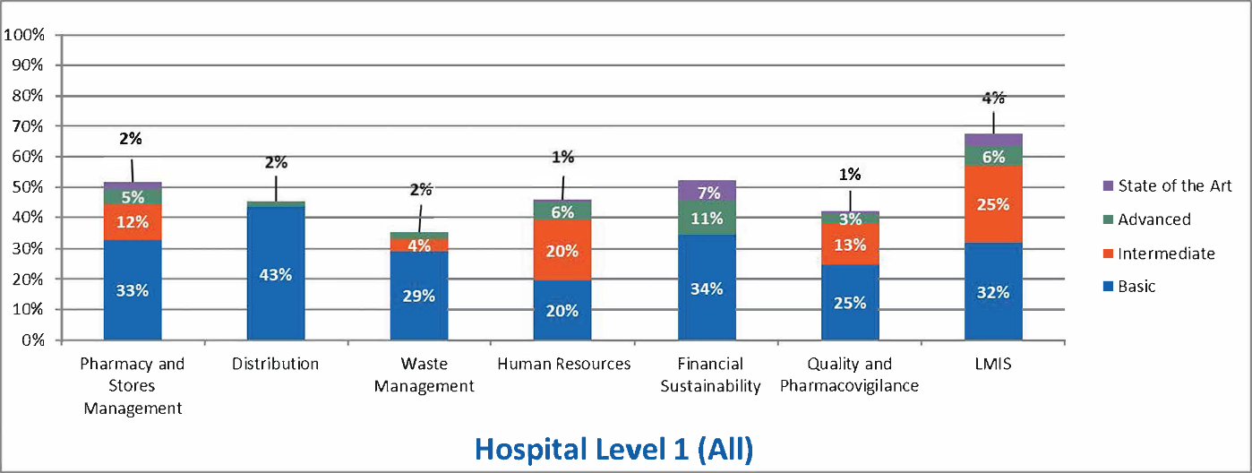

Maximum score for Basic is 50%; for Intermediate, 30%; for Advanced, 15%; for State of the Art, 5%. For instance, if the Basic portion is actually 45%, it should be interpreted as 45/50.

**Table 24. Select KPI results for LVL1H**

|  |  |
| --- | --- |
| Indicators | LVL1H |
| Average # of days per month with stock outs (overall for tracer commodities) | 14 |
| % of tracer commodities, out-of-stock on day of visit (overall) | 6% |
| % of orders delivered on promised delivery date (of all orders) | 35% |
| % of emergency orders, out of all orders | 10% |
| *% of facilities with any stock outs of any of the 10-tracer commodities October 2016–March 2017* | 99% |

Summary of Results

Overall maturity scores at the LVL1H was average across modules with a range of 35%–67%. Waste management (35%) had the lowest score, and LMIS had a fair capability score of 67%. On a positive note, QPV data that is collected is shared with the central and higher-level authorities in 82% of hospitals, access to controlled substances is limited to designated personnel in all LVL1H hospitals, and both internal and external audits are performed at the hospital pharmacy stores; however, only 6% of hospitals had pharmacovigilance SOPs. Operational security measures for the pharmacy stores did not include people entering and exiting the store in all the hospitals. The KPIs at the LVL1Hs were poorer compared to HC level with the average number of days per month out of stock at 14 days, only 35% of orders delivered on the promised delivery date, and 99% of facilities that had recorded any stock out between October 2016 and March 2017.

Discussion

It can be observed that the capability of the SCM areas does not necessarily translate into performance of KPI scores. From the scores, capability maturity was above average compared to the poor KPI scores. The average maturity scores influence service delivery at the LVL1Hs. Improvement in the capacity at this level is paramount to improve performance of the relevant indicators at this level. With QPV results shared with the higher authorities, it is expected that follow up is conducted at the affected hospital. A lack of SOPs for pharmacovigilance could affect the process and activities to follow when conducting pharmacovigilance activities. Though the security measures at the hospital pharmacy are not operational, losses due to pilferage, theft, and expiries are minimized due to the regular internal and external audits performed.

Recommendations

* Inventory management and control need to be strengthened through training, supportive supervision, mentoring, and data quality reviews.
* MOH should establish an action plan to improve KPI performance to match that expected for the CMM maturity level recorded and to improve patient services at these facilities.
* Operationalization of pharmacovigilance (PVG) should be guided by appropriate policies from which strict guidelines, and SOPs should be developed to influence activities such as ADR receipts and reporting. Once these policies are put in place at the central level, LVL1Hs should develop appropriate SOPs for the system.
* Strict security measures must be in place as part of a security protocol to ensure that access to pharmacy stores is controlled and authorized entry and exit must be properly documented at all times and records kept in a secure place.

### Level 2 & 3 Hospitals (LVL2/3H) (Government)

**Table 25. LVL2/3H CMM score by module (average score and range) (N=6)**

|  |  |  |  |
| --- | --- | --- | --- |
| Module | Average % | Module | Average % |
| Forecasting and supply planning | 65%  (45%–58%) | Human resources | 57%  (23%–74%) |
| Procurement | 67%  (42%–73%) | Financial sustainability | 58%  (47%–73%) |
| Pharmacy and stores management | 61%  (54%–74%) | Policy and governance | - |
| Distribution | 69%  (69%–69%) | QPV | 57%  (15%–95%) |
| Waste management | 56%  (19%–83%) | LMIS | 67%  (52%–77%) |
| Strategic planning and management | 48%  (0%–88%) |  |  |

**Figure 21. LVL2/3H (government) of achievement by functional area**

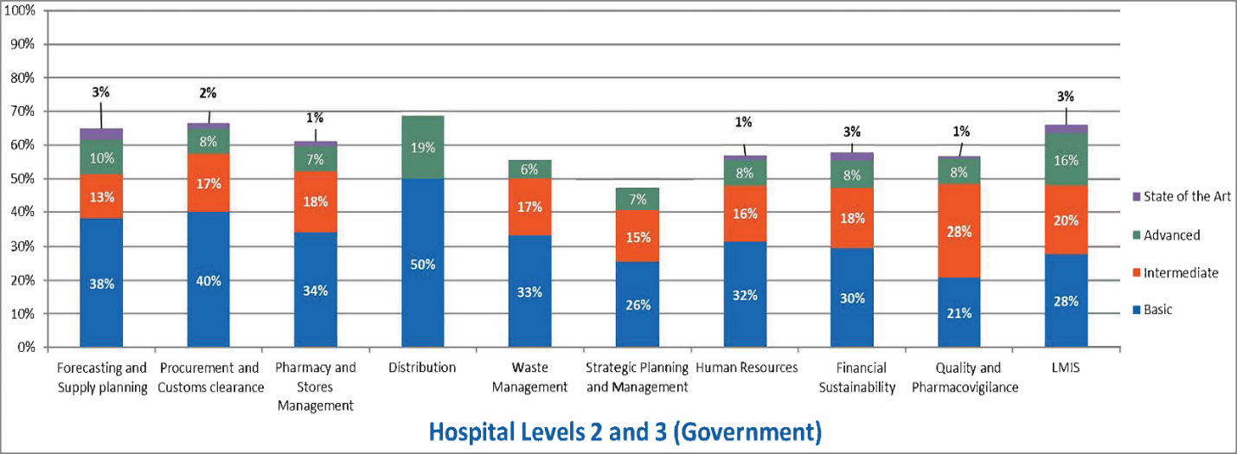

Maximum score for Basic is 50%; for Intermediate, 30%; for Advanced, 15%; for State of the Art, 5%. For instance, if the Basic portion is actually 45%, it should be interpreted as 45/50.

**Table 26. Select KPI results for LVL2/3H (govt)**

|  |  |
| --- | --- |
| Indicators | LVL2/3H government |
| Average # of days per month with stock outs (overall for tracer commodities) | 16.4 |
| % of tracer commodities, out-of-stock on day of visit (overall) | 15% |
| % of orders delivered within two days of promised delivery date | 48% |
| % of emergency orders, out of all orders | 37% |
| % of facilities with any stock outs of any of the 10-tracer commodities December 2016–May 2017 | 100% |

Summary of Results

The CMM at LVL2/3H hospitals is satisfactory, with a range of 48%–69%. Strategic planning and management (48%) was below average; however, distribution (69%), LMIS (67%), and procurement and custom clearance (67%) all had very good capability maturity. The KPIs, however, were low with average days per month with stock outs of tracer commodities at 16.4 days, 15% of tracer commodities were out of stock on the day of assessment, and only half of the orders were delivered within the promised delivery date. Emergency orders were the highest of all the service levels at 37% of all orders, indicating heavy reliance on emergency orders to compensate for low KPI performance. One hundred percent of the facilities had experienced a stock out of the tracer commodities between October 2016 and March 2017. There is a process for submitting unbudgeted requests. Checks made for inbound shipments include quantity, quality, and documentation. The pharmacy store room temperature was monitored and recorded and up to date within two days. However, the strategic plan did not include concrete actions to improve supply chain design and performance in all the LVL2/3Hs. There was no repair and maintenance plan in place for equipment and utilities in 83% of hospitals.

Discussion

Just like at the LVL1Hs, the satisfactory maturity scores were not commensurate with the low KPI scores. Stock outs were solved by a high percentage of emergency orders. Providing emergency orders is not a sustainable mechanism of solving the stock-out problem, as it becomes expensive in terms of staff time, handling, and distribution costs, contributing to poor value for money. The LVL2/3Hs have a mechanism for submitting unbudgeted requests, which enables flexibility in obtaining resources in case of an emergency. The quality of commodities is assured in the LVL2/3H hospitals due to the monitoring and recording of store temperature. However, the strategic plan at this level needs to be designed in such a way that actions to improve supply chain design and performance are inclusive of all service levels.

Recommendations

* An SC strategic plan should be designed to include actions to improve supply chain design performance. This should include an M&E plan for monitoring the system performance and a clear policy and plan for redesign as may be required in the event of system failures or inadequacies. The review plan should include use of lessons from operationalization of the system to make changes required to improve implementation.
* A well-structured repair and maintenance policy should be instituted. It should be centrally coordinated from the MOH. This should be made a culture of the entire SC system, and all staff should adhere strictly to this culture.

### Level 2 & 3 hospitals (LVL2/3H) (CHAZ)

**Table 27. LVL2/3H CMM score by module (average score and range) (N=1)**

|  |  |  |  |
| --- | --- | --- | --- |
| Module | Average % | Module | Average % |
| Forecasting and supply planning | 38% | Human resources | 56% |
| Procurement | 52% | Financial sustainability | 53% |
| Pharmacy and stores management | 55% | Policy and governance | - |
| Distribution | 51% | QPV | 15% |
| Waste management | 41% | LMIS | 49% |
| Strategic planning and management | 28% |  |  |

**Figure 22. LVL2/3H (CHAZ) of achievement by functional area**

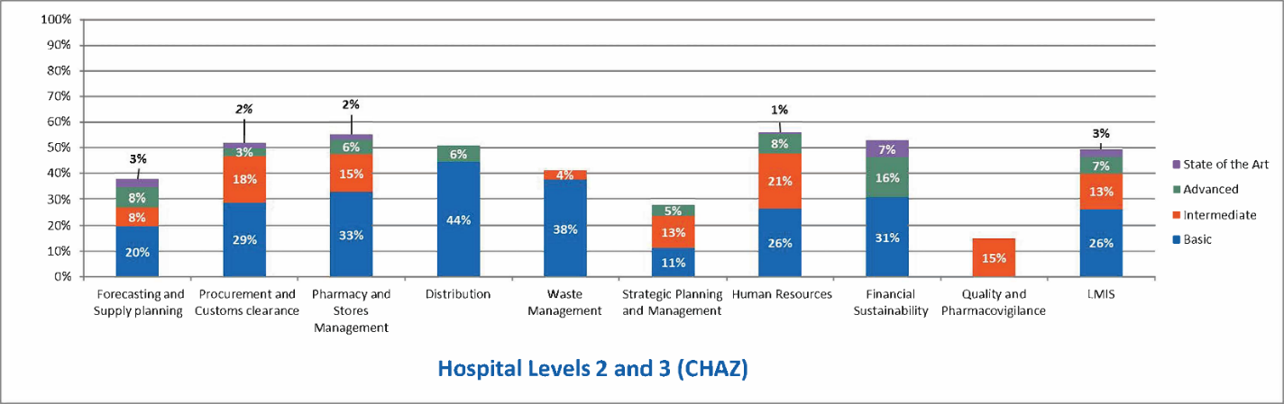

Maximum score for Basic is 50%; for Intermediate, 30%; for Advanced, 15%; for State of the Art, 5%. For instance, if the Basic portion is actually 45%, it should be interpreted as 45/50.

**Table 28. Select KPI results for LVL2/3H (CHAZ)**

|  |  |
| --- | --- |
| Indicators | LVL2/3H CHAZ |
| Average # of days per month with stock outs (overall for tracer commodities) | 16.8 |
| % of tracer commodities, out-of-stock on day of visit (overall) | 3% |
| % of orders delivered on promised delivery date | 46% |
| % of emergency orders, out of all orders | 30% |
| % of facilities with any stock outs of any of the 10-tracer commodities October 2016–March 2017 | 67% |

Summary of Results

The overall capability maturity scores were varied at the CHAZ LVL2/3H hospital with a range of 15%–56% of a maximum of 100%. Basic maturity scores range from 0% to 44% of a maximum of 50%. QPV scored 0% for basic maturity, a sign that there are no QPV systems at this level. Strategic planning and management and forecasting and supply planning had a very low maturity. On a positive note, waste management, pharmacy and stores management and distribution had good maturity. KPIs were fair, with 46% of orders delivered on the promised delivery date, only 3% of tracer commodities stocked out on the day of the assessment, and 67% of facilities with a stock out of any of the 10 tracer commodities between October 2016 and March 2017. The average days out of stock was still high at 16.8 days. The achievements and gaps for the LVL2/3H CHAZ supported hospital were similar to those of the LVL2/3H government hospitals.

Discussion

It should be noted that only one LVL2/3 CHAZ hospital was visited, so these findings may not be representative of all CHAZ LVL2/3H. Low capability scores in strategic planning and management and forecasting and supply planning creates a gap at the CHAZ LVL2/3H, in terms of long-term strategic planning to improve SCM and forecasting for commodities. The lack of QPV policies and procedures poses a risk to patients consuming substandard and poor-quality drugs. The KPI performances were fair; however, improvement is required in reducing the number of days out of stock of the tracer commodities and the percentage of commodities that have stocked out within a period of six months.

Recommendations

* A more in-depth review of the use and application of QPV principles, documentation and tools by LVL2/3Hs is needed. This should form the basis of devising targeted interventions to resolve low capabilities for this functional module. Cross-fertilization of practices between LVL1H and LVL2/3H could be beneficial, given the stronger performance in LVL1Hs.
* Capacity gaps in forecasting and supply planning need to be addressed. A targeted capacity assessment should be conducted to inform any capacity-building interventions in forecasting and supply planning. Innovative capacity building models such as linkages to long-term training institutions, peer networks, or communities of practice need to be introduced to develop and sustain workforce capacity in forecasting and supply planning.
* An SC strategic plan should be designed to include actions to improve supply chain KPI scores. This can be done by developing an M&E plan for monitoring the system performance, and a clear policy and plan for redesign as may be required in the event of system failures or inadequacies.
* A well-structured repair and maintenance policy should be instituted. It should be centrally coordinated from the MOH. This should be made a culture of the entire SC system, and all staff should adhere strictly to this culture.

### Regional hubs (RHBs)

**Table 29. RHBs CMM score by module (average score and range) (N=4)**

|  |  |  |  |
| --- | --- | --- | --- |
| Module | Average % | Module | Average % |
| Forecasting and supply planning | - | Human resources | 44%  (32%–56%) |
| Procurement | - | Financial sustainability | - |
| Pharmacy and stores management | 47%  (36%–57%) | Policy and governance | - |
| Distribution | 63%  (40%–74%) | QPV | 17%  (3%–41%) |
| Waste management | 17%  (0%–47%) | LMIS | 26%  (9%–51%) |
| Strategic planning and management | - |  |  |

**Figure 23. RHBs achievement by functional area**

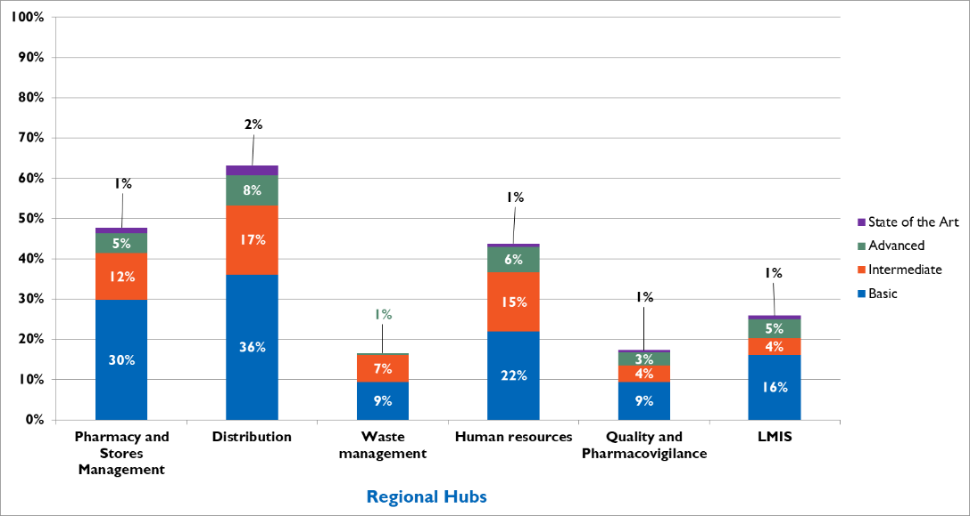

Summary of Results and Discussion

Scores for basic elements at the hubs were generally low for all six relevant modules. Pharmacy stores and management had 30% score of maximum 50%, while the distribution had a score of 36% and 9% score out of 50% for waste management. The score for HR was 22%, 9% for QPV, and 16% for LMIS.

The score for waste management is expectedly low, because activities are actually carried out centrally by a private company under supervision by staff from ZAMRA, law enforcement agents, and other stakeholders. It is also noteworthy that the hubs were still being rolled at the time of the assessment in Zambia and thus not fully integrated as part of the supply chain system. As such, these low scores are not a complete surprise.

Achievements show that the hub stores meet the minimum design standards for storage of health commodities, but there are gaps in some of the activities in the hubs that are not in line with best practices in health commodity storage (such as monitoring of humidity within the store and keeping records of the humidity).

Recommendations

* It is recommended that the hubs should be strengthened to become integral parts of the supply chain system in Zambia to help decentralize commodities storage and distribution away from MSL.
* Best practices in health commodity management should be adopted for all the hubs and storage facilities.

### Medical stores limited (MSL)

**Table 30. MSL CMM score by module (average score and range) (N=1)**

|  |  |  |  |
| --- | --- | --- | --- |
| Module | Average % | Module | Average % |
| Forecasting and supply planning | - | Human resources | 53% |
| Procurement | - | Financial sustainability | 50% |
| Pharmacy and stores management | 58% | Policy and governance | 14% |
| Distribution | 69% | QPV | 50% |
| Waste management | 54% | LMIS | 46% |
| Strategic planning and management | 46% |  |  |

**Figure 24. MSL of achievement by functional area**

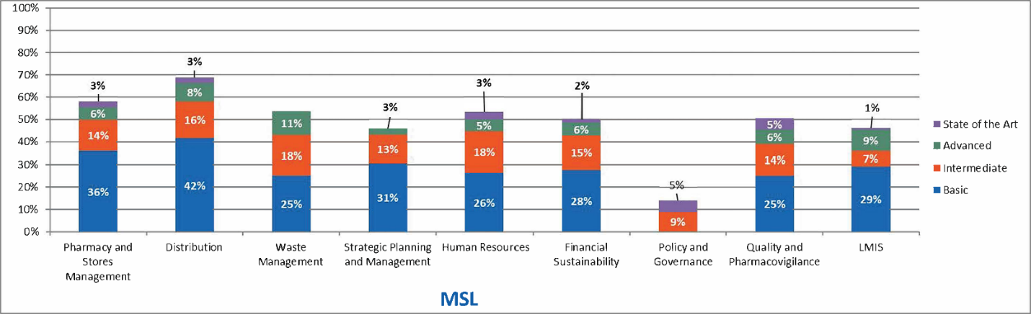

Maximum score for Basic is 50%; for Intermediate, 30%; for Advanced, 15%; for State of the Art, 5%. For instance, if the Basic portion is actually 45%, it should be interpreted as 45/50.

**Table 31. Select KPI Results for MSL**

|  |  |
| --- | --- |
| Indicators | MSL |
| % of tracer commodities, out-of-stock on day of visit (overall) | 0% |
| Stocked-according-to-plan (tracer commodities) | 13% |
| % of orders delivered on promised delivery date | 14% |
| Stock turn per annum | 1.2 |
| Order turnaround time | 26.4 days* |
| Order adjustment rate | 0%–100%** |
| Percentage of days with temperature outside acceptable range (cold chain) | 0% |
| Cost of warehouse operations as a percentage of total value of commodities managed by the warehouse | 5.6% |
| Cost of distribution operations as a percentage of total value of commodities managed by the warehouse | 0.5% |

*Routine orders only.

**Routine orders only; does not include adjustments made for incorrect calculations at health facilities.

Summary of Results and Discussion

The overall CMM results for MSL show low-to-average scores in all the modules applied except for distribution, which has a high score (69%) and pharmacy and stores management, which has an above-average score of 59%. The low-to-average scores are particularly evident at the basic maturity level as evidenced by the following scores: waste management (25%), strategic planning and management (31%), HR (26%), financial sustainability (28%), QPV (25%), and LMIS (29%). The score for basic elements for policy and governance is 0% because this is done at the MOH and not at the MSL.

The performance of distribution is high at 42% out of a maximum score of 50% for basic elements, which is expected as this is a key activity for MSL. The low score for LMIS (29% out of 50%) is a surprise as the activities of distribution should be dependent upon the LMIS reports. Thus, these low scores for LMIS may imply that while distribution is being done efficiently and effectively, the commodities may not be supplied in the right quantities.

Recommendations

* Many relevant KPI data were not available to the assessment team. MOH and MSL should assess the KPI performance as matter of urgency and establish an action plan to improve basic capability maturity for functions key to MSL’s role such as stocked according to plan, stock outs, and other pharmacy stores management.
* MOH should support MSL to ensure that appropriate policy guidance and strategic plans are in place that reflect the MOH policies and strategic plan and implemented to guide operations.
* It is recommended that the LMIS should be strictly reviewed and used in resupply decisions for the health facilities and hubs.
* Capacity building should be intensified to ensure that relevant MSL staff are able to prepare, submit, review, and use quality LMIS reports on time.

### CHAZ Central Warehouse

**Table 32. CHAZ central warehouse CMM score by module (average score and range) (N=1)**

|  |  |  |  |
| --- | --- | --- | --- |
| Module | Average % | Module | Average % |
| Forecasting and supply planning | 48% | Human resources | 33% |
| Procurement | 62% | Financial sustainability | 30% |
| Pharmacy and stores management | 58% | Policy and governance | - |
| Distribution | 71% | QPV | 69% |
| Waste management | 74% | LMIS | 48% |
| Strategic planning and management | - |  |  |

**Figure 25. CHAZ central warehouse achievement by functional area**

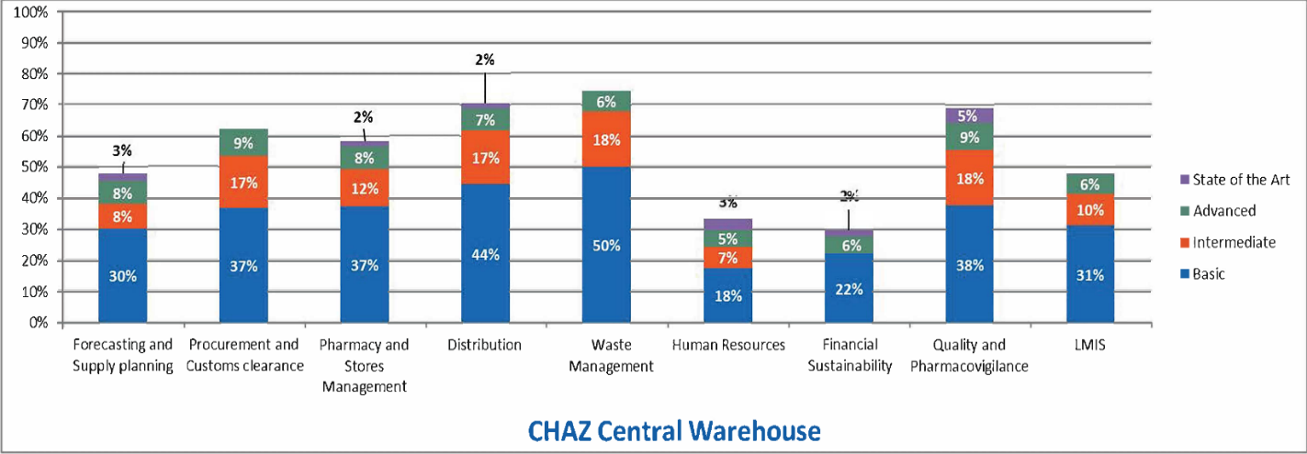

Maximum score for Basic is 50%; for Intermediate, 30%; for Advanced, 15%; for State of the Art, 5%. For instance, if the Basic portion is actually 45%, it should be interpreted as 45/50.

**Table 33. Select KPI results for CHAZ**

|  |  |
| --- | --- |
| Indicators | CHAZ |
| Average # of days per month with stock outs (overall for tracer commodities) | 13.5 |
| % of tracer commodities, out-of-stock on day of visit (overall) | 0% |
| % of orders delivered on promised delivery date | 21% |
| % of facilities with any stock outs of any of the 10-tracer commodities October 2016–March 2017 | 100% |

Summary of Results and Discussion

CHAZ central warehouse CMM score was high only for waste management, which was at the maximum 50% for basic and 44% of a possible maximum 50% for distribution. All other modules scored lower between 17%–38% for basic elements.

CMM achievements include the existence of a funding strategy as part of the overall business plan or strategic plan as well as a reasonably well-structured and laid-out warehouse with storage areas meeting the required minimum standards for carrying out best practices in warehousing and commodities management.

Gaps exist in the area of inadequate funding to achieve the objectives contained in the CHAZ current-year work plan.

Recommendations

* CHAZ management should establish an urgent action plan to improve relevant KPI scores.
* CHAZ needs to explore innovative financing mechanisms to support its business plan. This may include collaborating with other private sector partners and the government as part of public private partnerships. Conversely, CHAZ should assess its operations and highlight efficiency gaps that exist; these gaps should inform strategies for leaner operations, cost savings, and enhanced financial sustainability.
* CHAZ management needs to conduct an HR life cycle review and institute appropriate strategies (including capacity building) to address HR-related capability gaps.

### MOH and ZAMRA

**Table 34. MOH CMM score by module (N=1)—ZAMRA data included after the “/”**

|  |  |  |  |
| --- | --- | --- | --- |
| Module | Average % | Module | Average % |
| Forecasting and supply planning | 67% | Human resources | 84%/85% |
| Procurement | 95% | Financial sustainability | 59%/52% |
| Pharmacy and stores management | 74% | Policy and governance | 60%/83% |
| Distribution | 43% | QPV | /86% |
| Waste management | 80% | LMIS | 38% |
| Strategic planning and management | 77% |  |  |

**Figure 26. MOH levels of achievement by functional area**

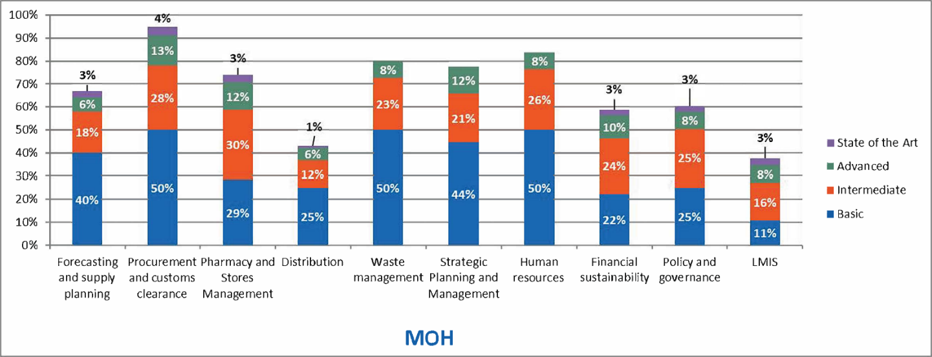

Maximum score for Basic is 50%; for Intermediate, 30%; for Advanced, 15%; for State of the Art, 5%. For instance, if the Basic portion is actually 45%, it should be interpreted as 45/50.

Summary of Results and Discussion

The CMM performance at the MOH was satisfactory for many of the modules applied. The scores for procurement and customs clearance, waste management, and HR were all at the maximum 50% for basic elements, while strategic planning and management and forecasting and supply planning were within the mature system range with scores of 44% and 40%, respectively. Distribution as well as policy and governance were at a low 25% each, while pharmacy and stores management scored 29% for basic. The score for financial sustainability was 22%, and LMIS scored the least at 11% for basic items.

Although LMIS is more focused at the MSL as the organization using the reports from the LMIS, MOH should also be involved, as these reports help in planning generally and specifically influence waste management, procurement, distribution, forecasting, and supply planning.

It is surprising that scores for financial sustainability should be low at the MOH. These are critical functions of the MOH. However, achievements include presence of specialized units in the MOH that handle elements of the supply chain including procurement, customs clearance , Quality and Pharmacovigilance is handled by ZAMRA, and a separate unit-handling forecasting and supply planning, and a human resource plan. Gaps exist in the areas of monitoring supply chain and other costs, absence of national maintenance and repair policy, and not developing an LMIS budget.

Recommendations

* MOH needs to conduct a business process analysis and LMIS technology review to determine issues related to the application of LMIS to Zambia supply chain operations. Strategies should be instituted as appropriate targeting the products of the business process and technology review. The MOH also needs to explore the identification of LMIS champions to entrench ownership, application, and use of the LMIS at all levels of the supply chain system.
* All costs associated with the supply chain should be monitored and recorded and used to assess efficiency of the supply chain.
* LMIS budgets should be developed by the MOH as part of the overall budget for the MOH.
* Appropriate policies and strategies should be developed for the supply chain in line with current trends and international best practices and disseminated to managers throughout the system.
* MOH needs to explore innovative financing mechanisms to sustain its operations. This may include collaborating with other private sector partners as part of public private partnerships. Conversely, MOH should assess its operations and highlight efficiency gaps that exist; these gaps should inform strategies for leaner operations, cost savings, and enhanced financial sustainability.

## Advanced Analysis: Relationship between the CMM and KPIs

To supplement the core assessment results from the NSCA 2.0 tool , a regression analysis was conducted to further explore the relationship between maturity scores and KPI levels (and among KPIs). The relationship between capabilities and KPIs was assessed based on a “root-cause”’-type analysis, including several regression models. This analysis identifies statistically significant correlations that suggest hypotheses for future investigation.

Higher capability scores are expected to lead to better performance, as measured by the KPIs. However, this is not always the case; some supply chain modules have been found to have low maturity and high performance. This situation can exist because lower capability scores present a risk to performance, and that risk may or may not be actualized within the time frame of the assessment. Areas of high risk (low capability maturity) that were not reflected in the KPIs scores (or that the KPIs did not measure) should also be considered as areas for improvements.

On the other hand, a supply chain may have high maturity and low performance in some areas. For areas identified as “poor performing” based on the KPIs, we assessed the related capability modules to determine (1) whether the poor performance is captured in the overall capability maturity scores and (2) if commonly missing key items (capabilities or infrastructure/systems) might explain the low performance.

Five KPIs were selected for analysis based on their ability to best capture the actual delivery of product. KPIs showing little variation were excluded, since no correlation would be found with maturity scores at all levels. Similarly, qualitative and process KPIs that could not be linked to maturity scores were excluded from analysis. The five KPIs analyzed as dependent variables were as follows:

* Average days out of stock (the average number of days per month a commodity was not in stock over the six months prior to the assessment, averaged across the 10-tracer commodities).
* Percent commodities out of stock on day of visit: the percentage of the 10-tracer commodities out of stock on day of the assessment visit.
* On-time delivery rate (the percentage of orders received by health facilities within two days of the promised delivery dates).
* Percent emergency orders: the percentage emergency orders out of all orders placed.
* Stocked according to plan (assessing the percentage of times the 10-tracer commodities were above the minimum and below the maximum amount in the stock plan, on the first day of the month for the six months prior to the assessment).

These KPIs were regressed—using the ordinary least square with robust standard errors—against the maturity scores for each module in the capability survey, the percentage of key supply chain staff leaving their positions in 2016, the supply chain staff vacancy rate on the day of the assessment, stock card accuracy, whether cold chain temperatures were tracked, and the level of the facility. Regressions were first run for all hospitals and HCs together and then reassessed for each level separately.

The regressions used a stepwise approach, where the regression was run with all variables, and the variable with the highest p-value was removed, and then the regression was re-run. This process was repeated until all variables remaining in the model had a p-value of <0.20. Because the HCs and hospitals were “clustered” within districts, robust standard errors were used to calculate p-values.

The results present factors that are correlated with the selected performance measures. These analyses have three caveats:

* Because there were only a few or limited observations from the hub and central levels, these levels could not be assessed in the regression analyses. Weaknesses in performance at the service delivery level may be the results of weaknesses at the hub or central level, and these relationships could not be assessed in these models.
* The regressions do not reflect causal relationships; interpreting the coefficients, for example, as “an X increase in maturity score will result in a Y increase in a particular KPI” would be an inappropriate use of the data.
* The relationship between capability maturity scores and KPIs is not always straightforward. The capability maturity scores reflect inputs and processes needed to have a fully functioning, low-risk supply chain, but not all of these elements relate directly to the individual KPIs assessed in these analyses.

The intent of the analysis is to help determine which modules/factors seem to have a relationship with performance and at which levels these modules/factors are correlated with performance. That is, the intention was to highlight areas of strength and weakness to prompt further investigation into underlying root causes when correlations are unexpected.

Few correlations were found between “average days out of stock” and capability maturity scores; only capability maturity scores for HR (higher score associated with less stock out) and QPV (higher score associated with more stock out) were found to have p-values below 0.20. “Stocked according to plan” also showed few correlations, with higher capability maturity scores for waste management and distribution associated with better stocked according to plan results. The results for these two KPIs are not further discussed.

Below each table of regression results is a brief discussion of some of the most relevant results and recommendations for further exploration. These recommendations are consistent with or complementary to recommendations throughout the document. Cells with no data indicate that the p-value was >0.20.

## Results of Multivariate Models

**Table 35. Percentage of out-of-stock, emergency orders, and on-time delivery**

|  |  |  |  |  |  |  |
| --- | --- | --- | --- | --- | --- | --- |
| Dependent variables | % commodities out of stock on day of visit |  | On-time delivery rate |  | % emergency orders |  |
|  | Estimate | p | Estimate | p | Estimate | p |
|  | n = 68 |  | n = 16 |  | n = 16 |  |
| Type of facility |  |  |  |  |  |  |
| HCs | Comparator |  | Comparator |  | Comparator |  |
| LVL1H |  |  |  |  | -0.15 | 0.000 |
| LVL2/3H |  |  | -0.51 | 0.005 |  |  |
| CHAZ ownership | Comparator |  | Comparator |  | Comparator |  |
| Govt ownership | 0.07 | 0.06 |  |  | 0.08 | 0.005 |
| Capability maturity scores |  |  |  |  |  |  |
| Waste management | -0.18 | 0.01 | -1.75 | 0.000 | 0.25 | 0.000 |
| LMIS | -0.22 | 0.000 | -0.50 | 0.14 | -0.20 | 0.024 |
| Distribution | 0.19 | 0.02 | -1.12 | 0.02 | 0.19 | 0.035 |
| Pharmacy and stores management |  |  | 6.52 | 0.000 | -0.94 | 0.000 |
| QPV | 0.11 | 0.08 | 0.27 | 0.09 | 0.35 | 0.000 |
| Financial sustainability |  |  | -2.39 | 0.000 | -0.15 | 0.033 |
| Human resources | 0.17 | 0.05 | 0.72 | 0.007 | -0.04 | 0.039 |
| KPIs |  |  |  |  |  |  |
| Stock card accuracy | 0.08 | 0.10 | -1.39 | 0.000 | 0.38 | 0.000 |
| Staff attrition |  |  |  |  |  |  |
| Staff vacancies | -0.06 | 0.02 | 0.37 | 0.01 |  |  |
| Temperature not tracked | Comparator |  |  |  |  |  |
| Temperature is tracked |  |  | -0.82 | 0.000 |  |  |
| No cool/cold storage |  |  |  |  |  |  |

Columns labeled “Estimate” show the beta coefficient from the regression—i.e., a one-unit change in the independent variable (listed at the left on the table) is associated with the beta coefficient change in the KPI. For example, in the first set of results, government ownership is associated with a 0.07 (i.e., 7%) higher percentage of commodities out of stock on the day of the assessment visit compared to CHAZ ownership.

## Discussion of Selected Results—Multivariate Analysis

### On-Time Delivery

LVL2/3Hs were less likely to receive deliveries within two days of the promised delivery date (“on-time delivery rate”) than HCs, although it should again be noted that orders with relevant data on dates were available only from two HCs visited for the assessment. Further, LVL2/3Hs reported only 14%–15% of deliveries as received within two days of the promised delivery date, and 50% of orders were delivered on or before the promised delivery date, indicating that half of deliveries were made more than two days after the promised delivery date. Since LVL2/3Hs had the best KPI results for this indicator among the different levels, on-time delivery appears to be a substantial issue in the Zambian supply chain.

Among the variables associated with on-time delivery, pharmacy and store management CMM, financial sustainability capability maturity scores, and stock card accuracy had the largest effect sizes (in absolute terms). This suggests that improvements in these areas may have the greatest impact on the on-time delivery rate. However, the exact nature of the relationship between these variables and on-time delivery rates is not clear for stock card accuracy—while stock card accuracy and order accuracy have an intuitive relationship, it is not clear how stock card accuracy would affect on-time delivery. Data collectors noted that more remote health sites often had lower service volumes, which meant they may have more time to work on stock cards but also potentially more likely to experience challenges with respect to delivery of commodities. Alternatively, it may indicate that health facilities experiencing frequent challenges with stocks (availability or ordering of commodities) are the most focused on keeping accurate accounts of their stock on hand because they are more pressed to manage their commodities.

Further, on-time delivery may be a function of hub and central level functioning rather than the functioning of service delivery sites, except insofar as service delivery sites need to place orders in time to allow the central and hub levels to deliver commodities on time. Order on-time rates were generally above 90% for government facilities (CHAZ facilities did not fare so well). Thus, we hypothesize that low on-time delivery rates may be caused by issues at the hub and central levels, and further investigation as to the root causes of low on-time delivery rates should focus on these levels.

### Emergency Orders

LVL1Hs were associated with having a lower percentage of emergency orders as compared to HCs, although it should be noted that these data were available only for one health center, meaning that this association is far from conclusive. However, the lack of data on both on-time delivery and emergency orders at the health center level is, in itself, an important finding, and efforts to have all levels of the health system track, understand, and report on-time delivery and the percentage of emergency orders.

As noted above, this result is largely for hospitals, because there was only one HC with available data. At the hospital level, one site accounted for one-third of the emergency orders enumerated among hospitals included the assessment (this site had 13 emergency orders, while all other hospitals had fewer than five emergency orders during the six months prior to the assessment). Thus, we hypothesize that tracking the emergency order rate and focusing on alleviating the issues that are causing emergency orders at specific sites with higher numbers of emergency orders is likely the most productive means of reducing emergency order rates.

### Stock Out on the Day of the Assessment Visit

A higher capability maturity scores in LMIS is associated with a lower percentage of stock out on the day of visit; this finding had the largest effect (in absolute terms) and lowest p-value. This suggests that consistent use of LMIS may have a positive impact on performance, and further investigation into the (correct and proficient) use of LMIS and how this may affect stock outs may be useful.

Large effect sizes for capability maturity scores related to waste management (higher score associated with lower stock out), distribution, and HR (both with higher scores associated with more stock out) were also noted. For HR, the result is in the opposite direction than was found for “average days out of stock.” We have not been able to generate any meaningful hypotheses from these results.

### Stepwise Regression Results for the Percent of Tracer Commodities Out-of-Stock on Day of Visit at Health Centers

We re-ran the stepwise regression model for the percentage of tracer commodities out of stock on the day of the assessment visit only including HCs in the analysis. We could not repeat the analyses for the LVL2/3H level because the number of these hospitals included in the analysis was limited; we could not repeat the analyses for on-time delivery and the percentage of emergency orders at the health center level because, as noted above, we were not able to collect sufficient data at this level.

**Table 36. Stepwise model: HCs (n = 44)**

|  |  |  |
| --- | --- | --- |
|  | Dependent variable |  |
|  | % commodities out of stock on day of visit |  |
|  | Estimate | p |
| CHAZ ownership |  |  |
| Govt ownership |  |  |
| **CMM scores** |  |  |
| Waste management | -0.15 | 0.2 |
| LMIS | -0.25 | 0.00 |
| Distribution |  |  |
| Pharmacy and stores management |  |  |
| QPV | 0.19 | 0.05 |
| Financial sustainability |  |  |
| Human resources | 0.23 | 0.03 |
| **KPIs** |  |  |
| Stock card accuracy |  |  |
| Staff attrition |  |  |
| Staff vacancies |  |  |
| Temperature not tracked |  |  |
| Temperature is tracked | 0.07 | 0.01 |
| No cool/cold storage |  |  |

### Discussion of Stepwise Regression Results at the Health Center Level

The stepwise multivariate model results are consistent with the full multivariate analysis—higher LMIS capability maturity scores are linked to lower percentage of stock out on the day of the visit, which is a potentially useful area for follow up.

### Stepwise Regression Model Results at the Hospital Level (Govt and CHAZ)

**Table 37. Stepwise model: LVL1H (all)**

|  |  |  |  |  |
| --- | --- | --- | --- | --- |
|  | Dependent variable |  |  |  |
|  | % commodities out of stock on day of visit |  | On-time delivery rate |  |
|  | estimate | p | Estimate | p |
| CHAZ ownership |  |  |  |  |
| Govt ownership |  |  |  |  |
| CMM scores |  |  |  |  |
| Waste management |  |  | -1.74 | 0.08 |
| LMIS |  |  |  |  |
| Distribution |  |  |  |  |
| Pharmacy and stores management | -0.81 | 0.00 | 9.44 | 0.03 |
| QPV | 0.33 | 0.01 |  |  |
| Financial sustainability | 0.30 | 0.07 |  |  |
| Human resources | -0.29 | 0.01 |  |  |
| KPIs |  |  |  |  |
| Stock card accuracy | 0.18 | 0.01 | -2.62 | 0.05 |
| Staff attrition | -0.16 | 0.06 |  |  |
| Staff vacancies |  |  |  |  |
| Temperature not tracked |  |  |  |  |
| Temperature is tracked | -0.14 | 0.00 |  |  |
| No cool/cold storage |  |  |  |  |
|  | n = 17 |  | n = 10 |  |

### Discussion of Stepwise Regression Results at the Hospital Level 1 (All)

As found for HCs, LVL1H hospitals with higher score for waste management have a lower percentage of ontime delivery rate

Pharmacy and stores management capability maturity scores are strongly and positively correlated with on-time delivery rates at these hospitals, which suggests that strengthening this technical area will result in better ordering practices.

As described in the full multivariate analysis, high stock card accuracy is correlated with higher percentage stock out and lower on-time delivery rate. The NSCA analysis cannot ascribe a strong connection between these variables, and we suggest this requires more investigation to discover how high stock card accuracy correlates to high levels of stock out and what other factors may be influencing this situation.

The high HR score correlates with lower percent stock out on the day of the visit. While this seems logical, it is an isolated finding and did not appear in the full multivariate analysis. This trend needs further confirmation.

Waste management, staff attrition, and staff vacancies show inconsistent results as with the full multivariate analysis and are probably statistical artifacts.

The stepwise multivariate model did not show any statistically significant difference at referral level given the low sample size of LVL2/3Hs.

# Limitations

Challenges and limitations experienced during the assessment included the following:

* The assessment is a snapshot of the supply chain system at a point in time. It does not provide trend information or change/improvement over time and may require further investigation into some of the data collected.
* The majority of relevant KPI data from MSL were not available to the assessment team.
* Insufficient time led to inability to collect all the data for CHAZ.
* Delayed retrieval of data at facilities was a significant challenge. Most of the data were manually retrieved, requiring more time at each facility. In other cases, the internet connections were slow, and eLMIS data could not easily be accessed. This resulted in a few cases of data (particularly eLMIS data) not being collected.
* Scheduling: Data collection was sometimes impacted by the two-day holidays. On scheduled days that were public holidays, some sites agreed to remain open for data collection. However, not all of these confirmed sites did remain open, and as a result, data could not be collected in some sites. In other instances, the sites confirmed that they would not be available due to public holidays, and the team rescheduled data collection to a day before or a day after the public holidays.

# Areas for Further Investigation

Routine KPI data were not available to the assessment team from MSL on measures such as timeliness of vendor deliveries, stocked according to plan and use of emergency orders. MOH and MSL management should review these data for comparison to the results of this assessment on other levels of the national supply chain.

KPI data on orders placed and deliveries received were not routinely available from the HCs. Here again, MOH may want to consider a sampling of HC orders to assess performance and if there is a heavy reliance on emergency orders. There was insufficient time in this assessment to investigate this area.

The lack of data on both on-time delivery and emergency orders at the HC level is, in itself, an important finding and worth further investigation to understand potential root causes for the lack of data available.

Following completion of the rollout of the RHBs, it is recommended that MOH and MSL conduct a review of the national distribution and stocking plans to identify any duplications, overlaps, and gaps that could be eliminated to further improve the efficiency of the distribution system, to reduce the time it takes to deliver commodities to the health facilities from MSL, RHBs and DHOs, and maximize the return from the investment in the hubs.

On-time delivery may be a function of hub and central level functioning rather than the functioning of service delivery sites. Orders were placed on time from over 90% of government facilities. Thus, we hypothesize that low on-time delivery rates may be caused by issues at the hub and central levels. Further investigation as to the root causes of low on-time delivery rates should focus on these levels.

Further investigation into the correct and proficient use of LMIS and how this may affect stock outs may be useful as a higher CMM score in LMIS is associated with a lower percentage of stock out on the day of visit in the full multivariate analysis. This suggests that consistent use of LMIS may have a positive impact on performance.

When the rollout of the eLMIS system is complete, the MOH will want to move to eliminate the redundant paper-based system, but it is recommended that the internet connectivity down to HCs in the “last mile” be reviewed. In some cases, paper may have to be retained, but this should be the exception, and means to lock these important last-mile facilities into the national system should be explored.

Stock turns per annum are reported as very low at 1.2 MSL and 1.7 in CHAZ. This is surprising given the high level of activity observed throughout the supply chain. This may be indicative of overstocking of some products at the central level or could be a result of errors in the underlying data that were collected. It is recommended that MSL and CHAZ review the data and consider how throughput can be increased if necessary.

Among the variables associated with on-time delivery, pharmacy and store management CMM scores, financial sustainability capability maturity scores, and stock card accuracy had the largest effect sizes (in absolute terms). The exact nature of the relationship between these variables and on-time delivery rates is not clear for stock card accuracy—while stock card accuracy and order accuracy have an intuitive relationship, it is not clear how stock card accuracy would affect on-time delivery. The NSCA analysis cannot ascribe a strong connection between these variables, and we suggest this requires more investigation to discover how high stock card accuracy correlates to high levels of stock out and what other factors may be influencing this situation.

The MOH and CHAZ should consider establishing a rolling program to assess whether the storage capacity of health facilities (hospitals and HCs) is sufficient to store the commodities within the maximum and minimum limits indicated as necessary to achieve stocked according to plan and reduce the risk of stock outs.

# Summary

The NSCA was conducted in Zambia during June and July 2017 at the request of the MOH, by Axios on behalf of USAID with the strong support of staff and managers throughout the public health system, and CHAZ to conduct surveys and gather data. The national supply chain (MOH and CHAZ) was mapped to show the flow of products and data, and the capability maturity of 11 functional requirements of the supply chain and 14 KPIs were assessed using NSCA 2.0 tools.

The assessment reflects the investments and innovations, such as the recently introduced eLMIS and the RHB in the national distribution system, made by the government and its international funding partners in recent years. It is important to recognize that rollout of the eLMIS and establishment of the RHBs is not yet complete, and this will have affected some of the assessment results. Once complete, one would expect the relevant capability maturity and KPI results to improve and be more consistent, across the system.

KPI results and CMM scores indicate that many of the key capabilities needed for a high-performing health supply chain exist in Zambia but are not consistently applied throughout the system. It was noted that in several areas, capabilities were assessed as being mature to the intermediate level, while there were still necessary basic capabilities outstanding. Improvement in the basic capabilities could mean that facilities or functions can progress rapidly to a more mature rating. Capabilities and KPIs at the central level are generally stronger than in patient-facing health facilities (hospitals and HCs). An improved use of planning tools such as demand forecasting, supply plans for distribution, pharmacy and stock management, and order management, supported by data-driven decisions derived from the eLMIS system applied by all units in the system, has the potential to raise performance levels and improve value for money throughout the system.

It is also important to recognize that although part of the national system serves a significant proportion of the population, CHAZ is a separate independently managed and financed nongovernment organization. Any comparisons between KPIs and/or capability maturity scores is merely reported as factual and does not carry any implied or actual criticism of either GRZ or CHAZ in their management and implementation of the health supply chain system in Zambia.

## KPI Findings

Stock outs are experienced throughout the system at HCs and hospitals; all patient-serving facilities had experienced a stock out of one or more tracer commodities during the six months prior to the assessment. In 15% of HCs, the main first-line ARV was stocked out on the day of the assessors visit, and around 17% showed a stock out of Artemether-Lumefantrine (AL) 6x4s, universally referred to in Zambia by the brand name Coartem. However, no HCs were stocked out of all AL weight bands meaning they had the ability to treat malaria. Encouragingly, neither MSL nor the CHAZ central warehouses were stocked out of any tracer commodity on the day of the assessor’s visit, which shows a prima facie potential to increase stock levels farther down the supply chain. Emergency orders are used by hospitals to correct or avert stock outs, showing a strong commitment to serve patients. But emergency orders are costly in level of effort and extra deliveries and should not be allowed to become a normal part of the supply chain system. Health centers do not capture data on emergency orders; therefore, it was not possible to assess if emergency orders are also prevalent at this level.

Contributing factors to the stock out challenges are as follows:

* Average stocked according to plan scores are low across the board with all tracer commodities reporting ranges of 6%–42% stocked according to plan with the one exception of Coartem at the CHAZ warehouse which is 100% stocked according to plan.
* Stock card accuracy is highly variable across all facility levels and tracer commodities.
* The majority of orders placed on MSL by facilities are adjusted, with the reason given that 67% of orders are adjusted due to stock out and 33% due to limited stock. Only for Depo Provera and malaria RDTs were no orders adjusted. CHAZ reports a need to adjust orders due to miscalculation by the health facility concerned.
* Order turnaround times are extended at 26 days for MSL and 16 days at CHAZ. A faster response to orders would be preferred and could reduce the need to resort to emergency orders to avoid stock outs.

In contrast to the strong maturity in forecasting and supply planning, accuracy rates for these plans, i.e., actual demand against that forecast and distribution and stocking according to the supply plan, are low in almost all areas. Improved implementation and routine assessment of forecast accuracy would support a further reduction in stock outs, improving patient experience, and deliver improved value for money.

Procurement KPI scores are good, although some pricing is above international norms and should be monitored to ensure continued good value for money.

Strong results were also seen in the following:

* Reported wastage rates are very low at less than 1% across all facilities. MSL reports that waste has not been disposed of in over a year, and this should be corrected with at least an annual disposal plan.
* MSL’s cost of warehousing and distribution is low compared to international averages at 5.6% and 0.5%, respectively.
* 89% of health facilities do not track data on temperature control of items that must be kept cool, although it must be noted that this is based on a limited sample size.
* Staffing levels are good, with few vacancies reported by either MOH or CHAZ.

## CMM Findings

Maturity scores for the central level at MOH and the CHAZ central warehouse are generally higher than farther down the supply chain, indicating that there is greater strain on the system and staff the closer the system gets to the patient. Maturity scores at the referral hospital level (LVL2/3H) are lower than at the central level (below 65% with a few exceptions). At LVL1Hs and HCs, most functions score below 55%. RHBs are a recently introduced key node in the government’s supply chain system and report maturity scores on par with HCs. The RHBs scored relatively well in distribution, which is their primary function as cross-docking stations, and as the process to fully establish these facilities is completed, other areas may need strengthening to improve overall performance in these facilities.

Despite relatively high maturity scores for eLMIS at all health facility levels, the legacy paper stock management system remains in use, with higher stock out rates where the paper LMIS is utilized. HCs reported challenges with internet connectivity, and RHBs reported challenges with shortages of skilled staff to operate the eLMIS. Given the advanced stage of eLMIS, it is recommended these challenges be addressed to enable the paper system to be retired and rely exclusively on eLMIS. This measure will strengthen pharmacy and store management performance and can be expected to contribute to reductions in stock out rates.

Forecasting and procurement report strong maturity scores at the central level.

Distribution is below the desired capability maturity scores for basic requirements and likely contributes to low stocked according to plan results and the frequency of stock outs. It is recommended that this be revisited when the RHBs are fully established and routinely serving all health facilities to assess if the results expected from the hubs are being achieved. It was reported that the DHOs are acting as an ad hoc buffer system for HCs facing stock outs. This should become unnecessary when the RHBs are fully operational and the role of the DHOs should be reassessed at that time.

Pharmacy and store management needs strengthening, particularly at the HC level. These disciplines are strongly linked to better performance on ordering to keep facilities stocked according to plan. Several respondents told our assessment team that they had insufficient space to hold all the commodities needed to the volume required to meet supply plans. It is recommended that the MOH and CHAZ establish a rolling program to assess available storage to support stocking to planned levels and where necessary seek funding support to add new capacity via options, such as storage-in-a-box, that can be introduced rapidly.

Financial sustainability shows less than 50% of basic capability maturity at all levels reporting on this function. This is largely due to the dependency on donor funding by both the government and CHAZ.

# Conclusions

This assessment of the GRZ’s national public health supply chain shows a system that is managed through a strong set of policies and central strategy driven by an ethos to serve patients and improve the health of the nation. As with all assessments, it has the limitation of being a snapshot in time of the reported capability maturity of the system at all levels and the results from an agreed set of KPIs. The assessment does not seek to be an in-depth diagnostic tool of specific supply chain technical areas but is able to draw conclusions on the correlation between capability maturity and performance in a number of areas, which point to potential actions to improve the performance of the system as experienced by the patient or where a deeper diagnostic analysis may be appropriate.

It is encouraging to be able to report good forecasting and procurement capability and performance; KPIs in distribution of the tracer commodities show a need for improvement, and stock outs remain common at all levels, but there is the potential for improvement as indicated by the results of the capability maturity assessment in distribution, and completion of the rollout of the RHBs. The costs of operation of the supply chain system are low, and levels of reported wastage are exceptionally low. An improved use of planning tools such as demand forecasting, supply plans for distribution and pharmacy stock management, and order management, supported by data-driven decisions derived from the eLMIS system applied by all units in the system, has further potential to leverage the capability maturity assessed, thereby raising performance levels and improving value for money throughout the system. Financial sustainability is relatively low, largely because of high dependency on international partner funding.

The Axios team would like to thank USAID for its support in this assessment and to pay tribute to the level of support received from the management and staff at all levels of the government and in CHAZ. This level of support further demonstrates the strong HR capability found in the assessment and the commitment of the staff and management to serving the health of their fellow citizens.

1. “Zambia,” World Health Organization, 2017, retrieved from <http://www.who.int/countries/zmb/en.>
2. “National Health Policy,” Republic of Zambia, 2012, retrieved from http://www.MOH.gov.zm/docs/National%20Health%20Policy%20-%20Final.pdf.
3. “National Health Policy,” Republic of Zambia, 2012, retrieved from http://www.MOH.gov.zm/docs/National%20Health%20Policy%20-%20Final.pdf.
4. “Human Resources for Health Planning & Development Strategy Framework,” Ministry of Health, 2017, retrieved from http://www.MOH.gov.zm/docs/NationalHRHPlanningAndDevelopmentStrategyFramework.pdf.
5. “Zambia National Health Strategic Plan 2017–2021,” Ministry of Health, 2017, retrieved from http://www.MOH.gov.zm/docs/ZambiaNHSP.pdf.
6. T. J. Ngulube, “The Zambia Country Case Study: Positive Practice Environments Quality Workplaces for Quality Care” (Geneva: Positive Practice Environments Campaign).
7. “Human Resources for Health Planning & Development Strategy Framework,” Ministry of Health, 2017, retrieved from http://www.MOH.gov.zm/docs/NationalHRHPlanningAndDevelopmentStrategyFramework.pdf.
8. “Health Sector Supply Chain Strategy and Implementation Plan,” Ministry of Health, 2017, retrieved from http://www.MOH.gov.zm/docs/impplanncss.pdf.